Name: Date:

gpb.org/water-journey

Student Guide: Develop and Use a Rain Gauge
Learning Targets: I can...
- ask questions about where water collects on our school campus.
- plan and carry out an investigation about rainfall on our school campus and where this rainfall goes.
- construct an explanation to the benefits of weather instruments in gathering weather data and making predictions.

Introduction
Do you know where your water comes from? In some places, water utilities pull fresh water from groundwater sources like aquifers. Some communities rely on water from wells. And some places, like counties and cities in metro Atlanta, rely on surface water. Surface water is water that flows on the surface of the earth, like rivers, streams, and creeks. Metro Atlanta, in the northern part of Georgia, sits on a thick layer of granite that covers most of the region. This unique geological feature prevents access to groundwater sources, which means that 99% of the region’s water comes from surface water. Luckily for metro Atlanta, the region receives an average of 50 inches of rain per year.

Guiding Questions:
How are we measuring rainfall? Where does this water go? (Please write your responses in complete sentences.)

Engage: What is the landscape like for our school campus? Develop a model of our school campus.

Use the model to anticipate and plan for the best location to collect rainwater. Label these possible locations. Add your symbol in the key.

Our School and its Surrounding Environment | Key

What are you wondering now? Ask questions about next steps for this water that could be investigated, modeled, or gathered from resources.

Explore: How are we measuring rainfall? Use the provided supplies to make a rain gauge.

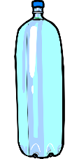

Possible structure for rain gauge:

With teacher approval, position your rain gauge on your school campus. Collect and organize rainfall data as the weather occurs.

Date | Amount of Rainfall | Observations of Sky Conditions | Other Observations of Landscape

Explain: How are we measuring rainfall?
- Develop and use a bar graph to represent the rainfall data.
- Include labels for the x-axis and the y-axis. Equal distance between measurements.
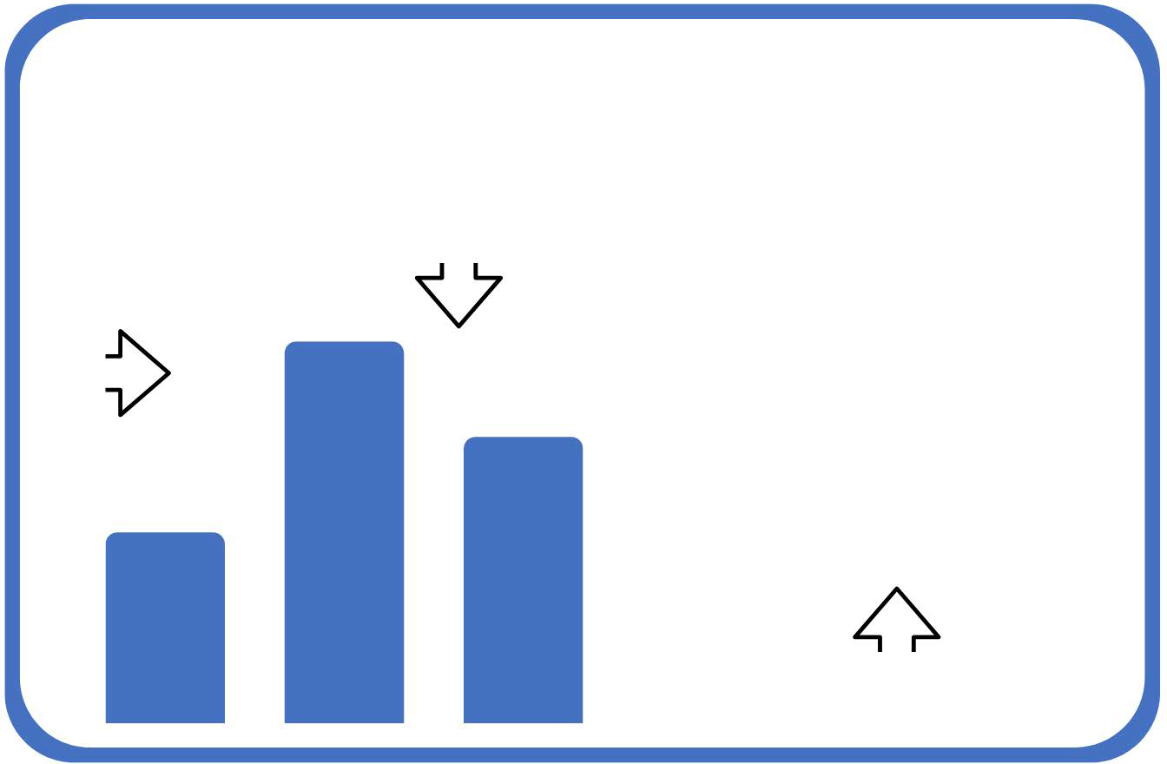
- Title the graph.
Title
equal spaces between data
y-axis
x-axis

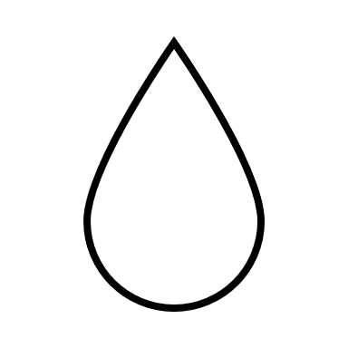
Caption the bar graph with an explanation for how the rain gauge supported your understanding of the benefits of weather instruments. Include answers to the following questions in your caption:
- Which day had the most rainfall recorded?
- Which day had the least?
- What is the average rainfall across the dates?
- How does the rainfall in your area compare to the rainfall in metro Atlanta?

Explain: Where did the water go?
Recreate your model of our school and its environment.

Our School and its Surrounding Environment | Key
Add to the model your other observations from the investigation. Show areas where rainwater moved, collected, or carried away soil and other sediment. Include labels and key to make your model easy to understand.

On the lines provided below, caption this model with an explanation for where the rainwater goes. Consider gathering additional information to show where the water goes once it leaves campus. For example, is there a nearby creek, pond, or river that it flows in? ...or does the ground absorb it? ...or is it a combination of both?

