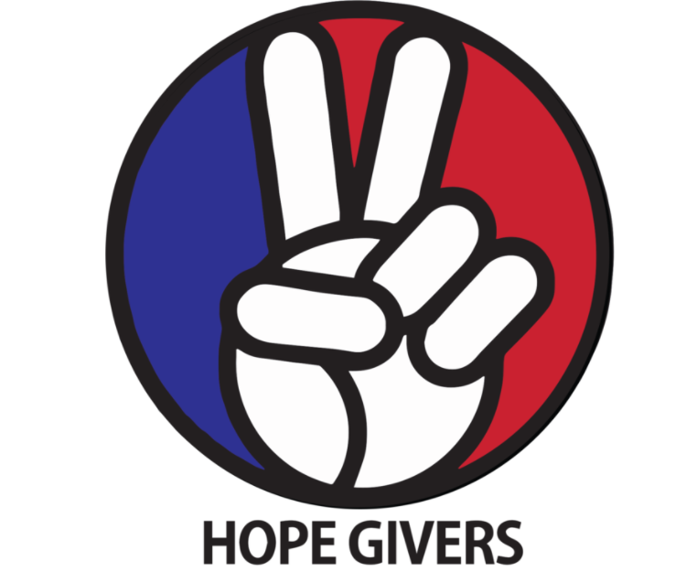
Hope Givers Season 2 Episode: 6
Grades: 6th-12th
Sample [Health Education] Instructional Plan

What Should Kids Get Out Of It?
Students should be able to know how to set goals (career readiness) and what steps need to be taken to reach those goals. Students should be able to identify healthy coping strategies and ways to take time for self-care. Students should be able to identify through self-reflection on what makes them unique and can give them confidence. Students should know that it is okay to follow their passions, goals and dreams.

Hope Givers Video Summary
What do you want to be when you grow up? How do you decide? Where do you want to go to school? Those are the questions that students are frequently asked. The episode tells us about a young entrepreneur named Chatejah George, she is the youngest production company owner in the world. The episode also discusses how students should follow goals, dreams, aspirations and passions. It does a Q and A with students about confidence and being unique and comfortable in their skin.

Standards Alignment
National HE Standards:

Standard 1: Students will comprehend concepts related to health promotion and disease prevention to enhance health.

Standard 2: Students will analyze the influence of family, peers, culture, media, technology, and other factors on health behaviors.

Standard 3: Students will demonstrate the ability to access valid information and products and services to enhance health.

Standard 4: Students will demonstrate the ability to use interpersonal communication skills to enhance health and avoid or reduce health risks.

Standard 5: Students will demonstrate the ability to use decision-making skills to enhance health.

Standard 6: Students will demonstrate the ability to use goal-setting skills to enhance health.

Standard 7: Students will demonstrate the ability to practice health-enhancing behaviors and avoid or reduce health risks.

Standard 8: Students will demonstrate the ability to advocate for personal, family, and community health.

Georgia HE Standards:

HEHS.1.c: Analyze how the environment and personal health are interrelated.

HEHS.1.g: Compare and contrast the benefits of and barriers to practicing a variety of healthy behaviors.

HEHS.2.a: Analyze how the family, culture, and environment influence the health of individuals.

HEHS.3.b: Investigate the accessibility of products and services that enhance health

HEHS.6.c: Analyze barriers and solutions to achieving health goals.

HEHS.6.d: Monitor progress in achieving short term and long-term personal health goals.

HEHS.7.b: Choose and implement a variety of healthy practices and behaviors that will consistently maintain or improve health.

HEHS.8.b: Demonstrate how to treat all individuals with respect and dignity. Learning how to appropriately disagree with others is a valued skill set.

Note: Standards are listed for High School Health in Georgia. Content may be used in middle school and standards listed may be changed to fit the needs of a middle school lesson plan. Please refer to the GSE for appropriate middle school standards. Content may also be used in other states and standards may be changed to fit those needs. Please refer to your own state standards for appropriate standards for your lesson plans.

Classroom Instruction
What is the main goal? Students should be able to set goals for their future. Students should be able to identify what is unique and special about them. Students should be able to identify what works for them in regards to self care.

Materials I need: Technology (To show the video), handouts as needed or an online version of some or all of the handouts (If you are paperless) White paper and coloring supplies.

What do the kids need to do? Watch the video, complete some or all the handouts/activities, participate in discussions, and create. Yes, it's that easy!

What do I need to do? Show the video to the class, lead discussions as needed, have students complete some or all of the handouts, pass out paper and art supplies for activities 1 and 2. And yes, it really is that easy!

Lesson Introduction: Where does anything new come from? Where do we get inventions, new recipes, new designs, new fashions, new apps, new medical procedures? Someone had to dream that up and make it happen. What “new” thing do you want to create?

Students are asked to make a list of their goals, dreams, anything they wish would happen in the world or to them.

Classroom Activities:
What do you dream of?
Goal Map
10 Things I love about me!

Lesson Closure: Set up students in an inner circle and an outer circle. Students will share their positive affirmations that they create and explain why they picked that. Students on the outer circle will move counterclockwise after 1 min to share with a new person.

How Do Teachers Know The Kids Are Successful?
At the end of this lesson, students should be able to look at their road map of life for the goals they want to accomplish. Students should acknowledge 10 things that make them unique and give them confidence to accomplish anything they set their minds to. Students should also recognize what self-care is needed for them individually.

How Do The Kids Know They Are Successful?
At the end of this lesson, students should be able to take their goal maps and set a possible course of action for themselves. Students should know they are unique, special and to be confident. Students can identify self care activities that are work for them.

Differentiation and Extension of Learning
Ideas for Differentiation:
Provide written material in languages other than English.
Incorporate different communities in your instruction. Ask students to share how they may think about a topic differently to pull information from various sources.
Provide students with both written material and visual material.
Break down work into smaller portions for students with accommodations.
Utilize small group time to provide more one on one instruction for students who need extended learning.
Pass out handouts/guided notes as needed for students.

Opportunities for Extension:

Inclusion Activities
Reach Out Campaign

Additional Resources

What are your hopes and dreams?

Write a list of any dreams you have. What do you wish you could accomplish, or change? Take a few minutes and write down anything you can think of.

1.
2.
3.
4.
5.
6.
7.
8.
9.
10.
11.
12.
13.
14.
15.
16.
17.
18.
19.
20
Goal Map

Description of the activity: Road Map
The purpose of this assignment is to get you thinking about your future. What do you want your life to be like? What accomplishments do you want to make? What goals have you or will you set for yourself? What important things do you want to make sure you are able to do? Choose at least 10 items that you would love to experience in your future.
Come up with a fun way to draw out/ design your future. Just because it is called a ‘road map’, does not mean you have to draw a road. You will need to use color and be creative.
Make sure you include the following for each item you decide to use:
- Tell what the item is
- A drawing/picture to represent each item
- Estimate or guess what age that item may happen
- Make your map colorful and neat
After students are done, they can get into groups of 3-4 and share their maps with their peers. These questions should be asked in the groups.
- What steps need to be taken to achieve that goal?
- What possible decisions you make could make it difficult to achieve that goal?
- Do you have trusted adults that you can go to for guidance or help to enable your success?

10 Things I Love About Me
Students will make a list of 10 things that makes them unique and gives them confidence or makes them special. Try to not have all the qualities be physical features. This will be easy for some and difficult for others. Be kind to yourself.
1.
2.
3.
4.
5.
6.
7.
8.
9.
10.

5 Self Care Techniques That Work For Me
Self-care is so important to our mental health. What are 5 healthy ways that you cope with life’s demands?
1.
2.
3.
4.
5.

