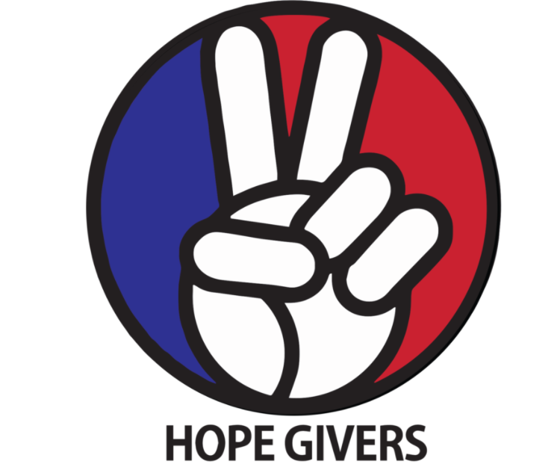
Sample [Health Education] Instructional Plan
Hope Givers Season 2 Episode: 5
Grades: 6th-12th
What Should Kids Get Out Of It?
Students should be able to understand what substance use and abuse are. Students should understand what addiction is and how it can affect other people around us. Students should be able to identify risky behaviors such as early alcohol and drug use. They should also be able to identify what trusted adults to talk to in order to get help for the road to recovery. Students should be able to identify healthy coping strategies that are unique to them. What is an affirmation? What can I do to avoid drugs and alcohol even if everyone else is using them? Students should also be able to use positive affirmations and healthy coping strategies to focus on mental, physical, and emotional health.

Hope Givers Video Summary
Substance use abuse, addiction and recovery. In episode 5 we learn about a woman who struggled with her addictions and found healthy ways to express herself through the arts. It discusses different healthy coping strategies that people can use to deal with Mental Health and substance abuse. We need to talk more about mental health. The video discusses how addiction can not only affect us, but the people around us. The video also shows what positive affirmations resonate with the students.

Standards Alignment
National HE Standards:

Standard 1: Students will comprehend concepts related to health promotion and disease prevention to enhance health.

Standard 2: Students will analyze the influence of family, peers, culture, media, technology, and other factors on health behaviors.

Standard 3: Students will demonstrate the ability to access valid information and products and services to enhance health.

Standard 4: Students will demonstrate the ability to use interpersonal communication skills to enhance health and avoid or reduce health risks.

Standard 5: Students will demonstrate the ability to use decision-making skills to enhance health.

Standard 6: Students will demonstrate the ability to use goal-setting skills to enhance health.

Standard 7: Students will demonstrate the ability to practice health-enhancing behaviors and avoid or reduce health risks.

Standard 8: Students will demonstrate the ability to advocate for personal, family, and community health.
Georgia HE Standards:

HEHS.1.c: Analyze how the environment and personal health are interrelated.

HEHS.1.g: Compare and contrast the benefits of and barriers to practicing a variety of healthy behaviors.

HEHS.2.a: Analyze how the family, culture, and environment influence the health of individuals.

HEHS.3.b: Investigate the accessibility of products and services that enhance health

HEHS.6.c: Analyze barriers and solutions to achieving health goals.

HEHS.6.d: Monitor progress in achieving short term and long-term personal health goals.

HEHS.7.b: Choose and implement a variety of healthy practices and behaviors that will consistently maintain or improve health.

HEHS.8.b: Demonstrate how to treat all individuals with respect and dignity. Learning how to appropriately disagree with others is a valued skill set.

Note: Standards are listed for High School Health in Georgia. Content may be used in middle school and standards listed may be changed to fit the needs of a middle school lesson plan. Please refer to the GSE for appropriate middle school standards. Content may also be used in other states and standards may be changed to fit those needs. Please refer to your own state standards for appropriate standards for your lesson plans.

Classroom Instruction
What is the main goal? Students should know the dangers of substance use and abuse. Healthy coping strategies for themselves. Create a positive affirmation. Where to go if they are struggling with addiction or someone they know so they can get on the road to recovery.

Materials I need: Technology (To show the video), handouts as needed or an online version of some or all of the handouts (If you are paperless) White paper and coloring supplies.

What do the kids need to do? Watch the video, complete some or all of the handouts/activities, participate in discussions, and create. Yes, it's that easy!

What do I need to do? Show the video to the class, lead discussions as needed, have students complete some or all the handouts, pass out paper and art supplies for activities 1 and 2. And yes, it really is that easy!

Lesson Introduction: Students are asked multiple choice questions as a prior knowledge evaluation. Students will hold up 1,2,3, or 4.

Question 1- Which substance is used most by teens
1- Marijuana
2-Alcohol- 7.0 million young people ages 12 to 20 reported that they drank alcohol beyond “just a few sips”
3- Nicotine
4- Tobacco

Question 2-
Are all over the counter drugs safe?
1 Yes
2 No
Question 3
Can smoking kill your tastebuds?
1-yes
2- no
Question 4
Do teens use smoking, alcohol or other drugs to deal with stress and mental illness?
1- yes
2- no
Question 5
Addiction only affects the people who are using and/or abusing the substances.
1- True
2- False

Classroom Activities:
What is an affirmation?
Creating your own affirmation.
Drug Free Ad

Lesson Closure: Set up students in an inner circle and an outer circle. Students will share their positive affirmations that they create and explain why they picked that. Students on the outer circle will move counterclockwise after 1 min to share with a new person.

How Do Teachers Know The Kids Are Successful?
At the end of this lesson, students should be able to be able to define an affirmation. Create their own affirmation and be able to share that with another student. Students should also be able to take the substance abuse quiz and answer the questions again with 100% accuracy.

How Do The Kids Know They Are Successful?
At the end of this lesson, students should be able to take their affirmations and keep them with them. Students will also know who they should report things to if they or someone they know is struggling with substance use/abuse or addiction.

Differentiation and Extension of Learning
Ideas for Differentiation:
Provide written material in languages other than English.
Incorporate different communities in your instruction. Ask students to share how they may think about a topic differently to pull information from various sources.
Provide students with both written material and visual material.
Break down work into smaller portions for students with accommodations.
Utilize small group time to provide more one on one instruction for students who need extended learning.
Pass out handouts/guided notes as needed for students.

Opportunities for Extension:

Inclusion Activities
Reach Out Campaign

Additional Resources
Attachments:
What is an affirmation?

Students should answer the following questions in the space provided. The teacher will ask students to share their answers with the class.

What is the textbook definition of affirmation? _____________________________________________________

__________________________________________________________________________________________

__________________________________________________________________________________________

What does having positive affirmations do for me? How is my definition different from the textbook definition?

__________________________________________________________________________________________

__________________________________________________________________________________________

__________________________________________________________________________________________

How can having a positive affirmation help you avoid using drugs and/or alcohol?

__________________________________________________________________________________________

_________________________________________________________________________________________

__________________________________________________________________________________________
How Would I Feel?

The students should write and describe 1-3 situations where they have been put into a situation where you have had to avoid drugs and alcohol. What did you do? Please answer the following questions in the form of a journal entry or online submission (Teacher discretion on how many to complete). If they cannot think of enough items, have the students think of a situation of what they would do if someone peer pressured them trying to get them to use drugs or alcohol.

Description of the activity:

How did you get out of peer pressure and the situation?

How can having goals, direction and positive affirmations help you to avoid risky behaviors or risky situations?

How can you help others to create their own positive affirmations and avoid drugs and alcohol?

How can you help someone struggling with addiction?

How do I create my own positive affirmation?

Students should get a white piece of paper and some coloring materials and they are creating their own positive affirmation phrases to keep somewhere they can look at everyday. Have them think about their affirmations and answer individually and what it means to them personally. Create and decorate your own positive affirmation.

- What statement speaks to me and makes me feel special?
- What motivates you?
- How are you treating the other people around you?
Examples
“Am I good enough? Yes I am”

“I am deliberate and afraid of nothing,"

"Who you are inside is what helps you make and do everything in life"

After students have had time to create their affirmation posters, gather them into groups of 3-4 and have them share their statements with their groups.

