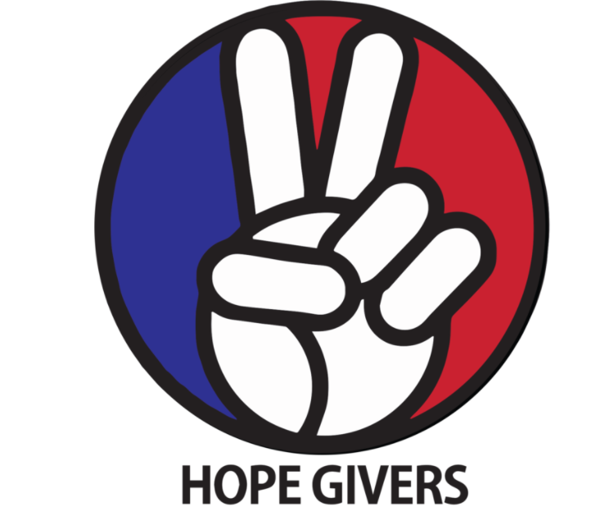
Hope Givers Season 2 Episode: 4
Grades: 7th-12th
What Should Kids Get Out Of It?
Students should be able to identify what depression is and ways to cope or help someone with anxiety and depression. They should summarize mental health and how it personally affects them. Students should practice self care and involve others in practicing self care as well. Students should practice mental health advocacy in several ways.

Hope Givers Video Summary
Mental Health Advocacy. Episode 4 highlights mental health through a young black neuroscientist(Charleese) who is struggling through mental health concerns, specifically depression and anxiety. Charleese utilizes self care to help maintain her hope through clay work and other means. The video also shows self care through positive affirmations and loving yourself no matter what.

Standards Alignment
National HE Standards:

Standard 1: Students will comprehend concepts related to health promotion and disease prevention to enhance health.

Standard 2: Students will analyze the influence of family, peers, culture, media, technology, and other factors on health behaviors.

Standard 3: Students will demonstrate the ability to access valid information and products and services to enhance health.

Standard 4: Students will demonstrate the ability to use interpersonal communication skills to enhance health and avoid or reduce health risks.

Standard 5: Students will demonstrate the ability to use decision-making skills to enhance health.

Standard 6: Students will demonstrate the ability to use goal-setting skills to enhance health.

Standard 7: Students will demonstrate the ability to practice health-enhancing behaviors and avoid or reduce health risks.

Standard 8: Students will demonstrate the ability to advocate for personal, family, and community health.

Georgia HE Standards:

HEHS.1.e: Propose ways to reduce or prevent injuries and health problems.

HEHS.2.b: Analyze how the culture supports and challenges health beliefs, practices, and behaviors.

HEHS.2.e: Evaluate the effect of media on personal and family health.

HEHS.2.f: Evaluate the impact of technology on personal, family, and community health.

HEHS.4.a: Demonstrate effective communication with family, peers, and others to enhance health.

HEHS.4.c: Demonstrate how to ask for and offer assistance to enhance the health of self and others.

HEHS.7.a: Demonstrate individual responsibility for improving personal health.

HEHS.8.b: Model strategies to influence and support others to make positive health choices.

HEHS.8.c: Coordinate with others to advocate for improving personal, family, and community health.

HEHS.8.d: Create health messages and communication techniques to target specific audiences.

NOTE: Standards are listed for High School Health in Georgia. Content may be used in middle school and standards listed may be changed to fit the needs of a middle school lesson plan. Please refer to the GSE for appropriate middle school standards. Content may also be used in other states and standards may be changed to fit those needs. Please refer to your own state standards for appropriate standards for your lesson plans.

Classroom Instruction
What is the main goal? Students should be able to identify anxiety and depression and ways to cope or help someone who has one or both of these mental health challenges. They should summarize mental health and how it personally affects them. They should also practice advocacy and advocate for mental health or people struggling with mental health issues.

Materials I need: Technology (To show the video), handouts as needed or an online version of some or all of the handouts (If you are paperless) Optional equipment for the mental health fair

What do the kids need to do? Watch the video, Complete some or all of the handouts/activities, Participate in discussions, Practice self care techniques. Yes, it's that easy!

What do I need to do? Show the video to the class, lead discussions as needed, Have students complete some or all of the handouts, Lead self care techniques in small or large groups. And yes, it really is that easy!

Lesson Introduction: The teacher should have the entire class put their heads down and close their eyes. Ask the class how many students have felt sad for long periods of time before. Record the number of hands that go up. Ask again how many have battled depression in the past. Record the number of hands. Ask how many have known a close friend or family member who have battled depression in the past. Record the answers. Now students can raise their heads. Share the data with the class. Chances are many of the students raised their hand at least once. Let me know that it is more common than they realize because not everyone discloses or shares what they are going through. Introduce the video for lesson 4 and begin playing the video.

Classroom Activities:
I love you tree
Mental Health Fair
Outreach Program
Anxiety: What is it?

Lesson Closure: Have students practice self-care by thinking of five positive things (affirmations) about themselves. Now, have students say out loud or share their positive affirmations with the class. Next, students should partner up and say five positive things about their partner. Students can share those with the class if time permits.

How Do Teachers Know The Kids Are Successful?
At the end of this lesson, students should be able to identify several types of mental health crises. Students should understand treatment options and how they can self manage mental health through self-care, stress management techniques, and positive affirmations.

How Do The Kids Know They Are Successful?
At the end of this lesson, students should be comfortable practicing self-care in a variety of ways. They should identify situations that may positively or negatively affect their mental health. Students should practice management techniques in a variety of ways and be able to help others do the same.

Differentiation and Extension of Learning
Ideas for Differentiation:
Provide written material in languages other than English.
Incorporate different communities in your instruction. Ask students to share how they may think about a topic differently to pull information from various sources.
Provide students with both written material and visual material.
Break down work into smaller portions for students with accommodations.
Utilize small group time to provide more one on one instruction for students who need extended learning.
Pass out handouts/guided notes as needed for students.

Opportunities for Extension:

Mental Health Advocacy Campaign
Mental Health Breaks
Love Campaign

Additional Resources
National Health Standards, Georgia Health Standards of Excellence, HECAT

Attachments:
I Love You Tree

First, you may include another teacher, such as an art teacher, to help you design or create a large tree mural to place in the hallway. A tree design is optional as it can be another design. You can even just use a board already placed on the wall.

Students should help decorate the tree with the theme ‘I Love You Tree’. You can do this in a variety of ways: Student volunteers, small or large groups that all help with one item etc.

Once the tree is complete in the hallway, students will each write 2-3 positive notes, messages, inspirational quotes etc on notecards or sticky notes. Collect all of the notes from the students and place them in small holders that you can attach to the tree.

Once the tree is complete with the notes, make an announcement to the school that if students are feeling down or sad, or simply need a pick me up, they can grab a note as needed from the tree to keep. Students from the school can also write notes to hand into the health teacher. Screen notes before placing them on the tree.
As notes run low, you can continue to have students add notes in class and make this an ongoing project throughout the school year.

Mental Health Fair
Teachers should select a date for a mental health fair and seek approval from the school administration and other personnel prior to this activity.

Have students work in small groups to come up with activities that could be included in a mental health fair. Give students 10-15 minutes to complete this task.
Next, students should share with the whole class and the class should create a master list of activities combining all activities from all of the groups.

Next, have students discuss and narrow down the master list to 4-5 activities.

Complete those steps for all health classes. The teacher will combine the final master list from all classes and narrow down to an appropriate number of activities for the health fair.

Once a final list is set, students will help plan out the activities and ensure that there is equipment for all of the activities. Create an organizational system for the health fair that can be shared with faculty, students, and community members.

EXAMPLE SYSTEM:

Time | Room | Supervision | Activity | Duration | Notes
3:00-3:30  4:00-4:30 | 105 | Mr. K | Yoga | 30 minutes | Yoga mat optional
4:00-5:00 | 110 | Ms. M | Open Mic- Poetry | 1 hour | Poem must be approved by admin
3:45-4:15  4:30-5:00 | Gym | Ms. L and Mr. T | Zumba | 30 minutes | May enter and leave early/late as needed
3:00-5:00 | Library | Mr. and Mrs. G | Relaxation Zone | Ongoing | Quiet music, discussions

Outreach Program
There are several ways to complete an outreach program targeting mental health. This is one option but there are many that can be utilized throughout the school year.

Teachers should utilize other faculty members for help (Counselors, Guidance, Admin, Other teachers) to help create a buddy list.
A buddy list is a list of seniors who pair with sophomores and juniors who pair with freshmen. In middle school you can change it to correlate with your grade levels.
Next, work with ELA/Lit teachers to have students write letters in their classes to their buddy. Start with the higher grade level. Have them write a short note to their buddy and include their full name and the full name of their buddy and their ELA or homeroom teachers.
Students in health will help deliver the notes to the correct teachers as needed as this can be a year long activity.

Ideas to write about:
About me
How to ‘survive’ high school
Tips to limit stress in high school/middle school
Advice about teenage or high school items
How to be successful in academics
Things they should try or be involved in
How to help with mental health
How to be successful in the future (During school or after graduation)
Other fun facts/items

Anxiety: What is it?
Students: Answer the following questions in the spaces provided.

In my own words, what is anxiety?

Have I ever experienced anxiety or panic attacks? If comfortable, share your experience or what caused the anxiety.

What are triggers? How can triggers be different for different people?

What are some things I can personally do to help reduce anxiety? For example: If I feel overwhelmed with too much school work, I can do a little each day, plan ahead, get extra work done when possible, take small breaks when I feel overwhelmed or stressed, ask for help when needed.

What are some things I can do to help other people who are feeling anxious or stressed?

