Concept 23 – Market Structures Companion Activity
Teacher Instructions
- Distribute one copy of the companion activity worksheet (page 3) to each student and instruct students to review the market structure readings—Microeconomics domain, concept 23—on Econ Express.
- Instruct students complete the Beginner activity on Econ Express and then record their responses in the chart on the companion activity sheet as a study tool.
- After providing students enough time to complete the chart (10-15 mins.) ask them to join in a conversation about the traits and examples of each market structure.
- Review their charts asking students to share their responses or comparing answers to a neighbor. Be sure to discuss how many buyers and sellers there are, how unique the product is, the ease of entering the market, and how much control individual sellers have over prices in each category.
Alternative examples for each market structure:
Pure Competition- commodity providers (farmers or fishermen; very few purely competitive markets.
Monopolistic competition- novels, movies, restaurants, tree service, beauty shops, locksmiths, churches.
Oligopoly- tennis balls, athletic apparel (national chain stores), national pharmacies, hotel chains
Monopoly- water, gas, or electricity providers
- Prompt students to review the Comprehension questions at the bottom of the companion sheet. Ask students which market structure they would prefer to operate within as a business owner. (Some students may respond they would like to operate within a monopoly because they can control their own destiny: price and output. Remind these students that customers will not pay any price, and the government will likely regulate your firm if it is a true monopoly).
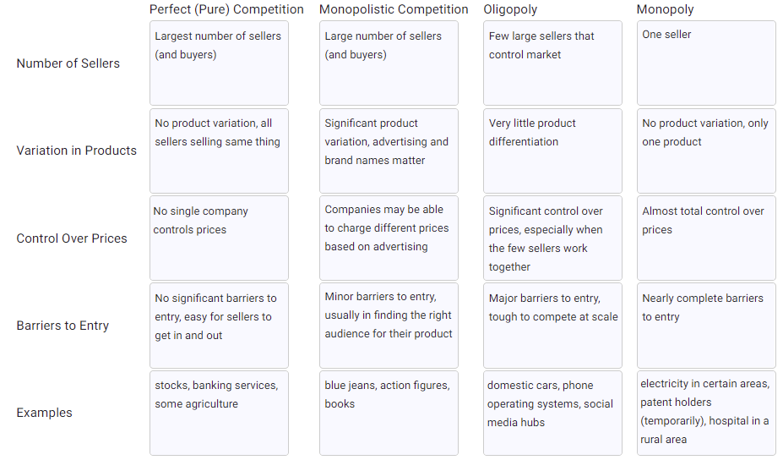
- Students should identify their dream job. Encourage them to be realistic and challenge them to write it down. Next, they should determine which market structure their selected business/job would likely operate within. Ask students to share some of the challenges the market structure may pose to their business’s success and long-term profit. (Hint: the more competition in the market the more difficult it will be to earn positive economic profits due to a lack of pricing power)
TEACHER KEY

Comprehension Questions:
- Answers will vary, but encourage students to be specific if they initially start with broad categories like “bakery” or “restaurant” or “website.” What kind? That might narrow their market structure.
- Answers depend on the answer to #1, but challenge students to justify their responses using their completed chart.
- In general, purely competitive companies face issues with making long-term profits since everyone is doing the same thing. Also distinguishing their product is tough. Companies in monopolistic competition face additional marketing costs to establish their brand. Oligopolies and monopolies face additional regulations and government oversight. Other issues like control over their price and levels of competition are important to consider.

Concept 23– Market Structures Companion Activity
All businesses compete against competitors (except for monopolies, of course) in product markets with unique characteristics. The types of competition within each market structure determines a firm’s output and the prices they will charge their buyers. There are four primary market structures which exist along a spectrum of competition from many sellers to just one seller.

Classroom activity: Markets function very differently depending on how many buyers and sellers there are, how unique the product is, the ease of entering the market, and how much control individual sellers have over prices. Using these variables, there are four distinct market structures:

Pure or Perfect Competition: markets where there are many buyers and sellers; all sellers are offering nearly identical products; entry is easy; and individual buyers and sellers have no control over price
Monopolistic Competition: markets where there are still many buyers and sellers, but the products are “differentiated” through quality, features, name-brand or advertising; entry is still easy; and sellers have limited control over price
Oligopolies: markets where there are few sellers selling similar products, giving them significant power over price and quantity in the market; it’s difficult for new sellers to enter due to high startup costs, brand loyalty or other factors
Monopolies: markets where there is literally one seller of a unique good, who has tremendous control over price and quantity in the market; entry is impossible due to patents, government protection or other factors

DIRECTIONS: After reviewing the four distinct market structures complete the organizer below.
 | Perfect (Pure) Competition | Monopolistic Competition | Oligopoly | Monopoly
Number of Sellers
Variation of Products
Control Over Prices
Barriers to Entry
Examples

1. If you were going to start a business, what kind of business would it be?

2. In which of the four market structures will your future business likely compete? How do you know?

3. What are some challenges of operating a business in this market structure given the level of competition you may face?

