Hope Givers Episode: 2, Jae & Rachel Grades: 9th-12th

Sample [Health Education] Instructional Plan

Enduring Understanding
After this lesson, students will be able to: 1) Recall prior knowledge, evaluate their own learning. 2) Identify human traffickers' stereotypes. 3) Map the three key elements of human trafficking and define the process.

Hope Givers Video Segment
In Season I: Episode 2: “Human Trafficking,” high school scholars will hear the story of Jae Carter and mentor, Rachel Thomas, Human Trafficking Educator. The story will show how it affected their mental health and self-esteem. Jae, who is a graduate student at the University of La Verne in La Verne California, was lured into human trafficking while in foster care. Afraid and confused, they were made to think the emotional and physical abuse they received was their own doing. They felt ashamed and kept this secret for years. After hearing Rachel’s story of being a victim of human trafficking and how she was able to rebuild her life afterward, Jae felt the connection and was able to share their story with Rachel and later to the world. They are now building an empowered and educated community to help victims of human trafficking globally.

Standards Alignment
National HE Standards:
Standard 2: Students will analyze the influence of family, peers, culture, media, technology, and other factors on health behaviors.
Standard 4: Students will demonstrate the ability to use interpersonal communication skills to enhance health and avoid or reduce health risks.
Standard 5: Students will demonstrate the ability to use decision-making skills to enhance health.
Standard 7: Students will demonstrate the ability to practice health-enhancing behaviors and avoid or reduce health risks
Standard 8: Students will demonstrate the ability to advocate for personal, family, and community health.

Georgia HE Standards:
HE7.4: Students will demonstrate the ability to use interpersonal communication skills to enhance health
and avoid or reduce health risks.
b. Demonstrate effective conflict management or resolution strategies and model refusal and negotiation skills that avoid or reduce health risks.
HE7.5: Students will demonstrate the ability to use decision-making skills to enhance health.
- Describe situations that can help or hinder making a healthy decision and identify situations where making those decisions are more likely to occur.
HE7.7: Students will demonstrate the ability to practice health-enhancing behaviors and avoid or reduce health
risks
- Create personal examples of healthy behaviors that will maintain or improve the health of self and/or others.
HE7.8: Students will demonstrate the ability to advocate for personal, family, and community health.

Instructional Design
Teaching With the End in Mind:
By the end of the lesson, students will be able to identify warning signs of a human trafficker, understand how our environment shapes our mental health, learn how to seek help for human trafficking victims, and identify coping skills related to human trafficking. Students will also learn ways that they can be advocates in their own communities to help prevent human trafficking.

Key Concept(s) to be Covered:
Trauma, PTSD, environment, self-care, mentorship, dependency, human trafficking, force, coercion, and fraud

Introduction to the Lesson 10 minutes:
- Activate Prior Knowledge: Using KWLQ strategy. Conduct the K and W part of the activity on human trafficking before viewing the video. Linking to prior learning and knowledge. What I know about human trafficking, what I want to learn. Remind students that we are discussing sensitive topics and if they feel uncomfortable to let you know.
- Class Discussion: Educator will host a brief discussion with students. Ask students why they feel mental health, self-esteem, trust, and self-care are important. Discuss the following terms with students: Force: using violence to control someone
Coercion: using threats to control someone
Fraud: using lies (false statements) to control someone

Hook (Instant Activity) 25 minutes:

Using the KW: What is Human Tracking?

Allow students to explain or provide examples of their definition (volunteers only). The teacher should be a moderator only during this portion.

Suggestions for how to complete this activity:

- Whiteboard.fi
  - This site allows you to view student’s computers and what they are writing. You could use the projector screen to showcase the site and have students type their answers. Only YOU will see it. You will ask them the following: “how do you define human trafficking?” Allow students to explain or provide examples of their definition (volunteers only). The teacher should be a moderator only during this portion.
- Jamboard.google.com
  - This site allows the students to create their own answers on a board. You can make multiple boards for them to write on. You can place this question on the first board “how do you define human trafficking?” Allow students to explain or provide examples of their definition (volunteers only). The teacher should be a moderator only during this portion.
- Post-it Notes
  - Pass out post-it notes and review the question of “how do you define human trafficking?”
  - You can choose to post them on your whiteboard for others to come view a few at a time OR you can review them with the students and ask them to come up with a similar definition based
on the other definitions. The teacher should be a moderator only during this portion.

Content, Learning & Instructional Strategies:
- Introductions
- Hook activities
- Watch Hope Givers Season 1: Episode 2 “Human Trafficking” the Jae Carter and Rachel Thomas story (13:13 minutes)
- Recap the video focus on students' interaction that address the following the LQ part of the activity:
o Ask students when focusing on the dimension and realities of human trafficking: Who does human trafficking affect? Why and how does it occur? What is PTSD and its causes? What are some things you can do to improve self-care? How can you be an advocate to help prevent human trafficking?

Learning Activity(ies):
Module I: 20 minutes-
Topic: Who is a Human Trafficker? Stereotypes, human trafficking as a process
Materials: Paper, color pencils, magazines staying safe online information sheet
Description/Activity: Students will draw or cut and paste a picture on the paper provided of what they think a human trafficker looks like. Ask students to share their drawings or pictures and explain the thinking behind the picture. Focus on patterns (similarities/stereotypes).

Key Message: A trafficker can be male or female who is involved in any act in the trafficking process and who exploits or makes a profit from victims at any stage of the trafficking process.

Module II: 40-45 minutes

Topic: Mapping the Three Key Elements in Human Trafficking

Materials: Human Trafficking Video, and Elements of Human tracking factsheet

Description: Explain to the students how human trafficking comprises the key elements: ACT: (what it is done) MEANS (how it is done) and The PURPOSE (why it is done).
-Students will watch a video that will include facts of human trafficking, the profile of a trafficker, and the victim's red flags. Apply the three elements of human trafficking to the video

Video (5:35 mins): What is Human Trafficking ?

Activity: Place students in groups. Each group will be assigned 1 of the 3 scenes from the video. Students will complete the digital handout by recording the information presented and will share it with the class. For example, Scene 3 is the recruitment of a little boy (free child labor) The group should present their findings.

Handout: Elements of Human Trafficking

Key Message: 1) Human trafficking should be viewed as a process rather than a single event. 2) Human trafficking can start with the recruitment of a person with or without consent and continues with the movement of the victim to another area. 3) It is important that students understand that a child (a person under the age of 18) cannot give consent) 4) The exploitation phase refers to when the victim is exploited or taken advantage of in some way, such as forced labor or sexual exploitation.

Module III: 20 minutes:

Topic: Make it Personal Journal Entry

Material: Laptops or Paper

Description: As a final activity, students will create a journal. Students can use digital or paper journals to express their feelings, acquired knowledge, plan of action in whatever they choose. Ask students to be creative with their expressions through writing; poems, essays, songs, digital animation, collages, etc.

This is an example. Place in the student journal, on the projector, or read to class:

Jazmine is a 13-year-old who had low self-esteem and did not have many friends. She loves to paint and listen to her favorite songs on her phone. She grew up in the suburbs of Atlanta, Georgia. While Jazmine was at the mall with friends last summer, a middle-aged man told her, “You’re beautiful.” Flattered, she stopped to chat. Later, Jazmine was reported missing by her parents.

Ten months later, the police reunited Jazmine with her parents due to a tip from a person who saw Jazmine on the streets of Chicago, Illinois, and recognized the signs of human trafficking. She was found bruised and drugged in a basement where she had been forced to have sex with men daily.

Jazmine has a long process of healing ahead of her, but due to the action of a person who recognized the signs, Jazmine’s life was saved and she has a hopeful future.

Items to include:
Digital Note Cards Digital Journal
Human Trafficking Information Activity Handout
Student Laptops Videos

Closing/Conclusion to the Lesson
Share with students by providing information with ways to stay safe and protect yourself
Additional Resources: Staying Safe, Protect Yourself Checklist (Attachment)
-Discuss with the student that these are ways/signs that they can look for in their classmates, friends, and/or peers.
-Share with students US Human Trafficking Resource Center National Hotline:

Relaxation 101: Have students each space out in an open space. It could be the gym, classroom, or even outdoors. Leave ample room to stretch out without touching someone else. Utilizing the Coping Skills for Kids Deep Breathing PDF, guide students through deep breathing exercises to help them relax. Ask them if they feel it helps and how they can utilize this technique in stressful situations.
Evidence of Student Success
Students will respond to the acquired knowledge and awareness of human trafficking through assessing their understanding. Describe the dynamics of human trafficking through the mapping, describe the available
community resources available locally and globally.

Student Learning Supports
Ideas for Differentiation:

- Provide written material in languages other than English.
- Incorporate different communities in your instruction. Ask students to share how they may think about a topic differently to pull information from various sources.
- Provide students with both written material and visual material.
- Break down work into smaller portions for students with accommodations.
- Utilize small group time to provide more one-on-one instruction for students who need extended learning.
- Pass out handouts/guided notes as needed for students.
- Read material aloud to the class to ensure that students draw the most important information from the lesson on human trafficking and mental health.
- Verify that students can interpret correctly what is human- trafficking
- Provide information on safe online practices

Opportunities for Extension:
Address the importance of self-esteem. Engage in exercises to challenge the media’s ideal of desirability and to define healthy relationships as a shield against traffickers who are looking for a target.

Additional Resources
Part I: Crime Stoppers Human Trafficking Interactive Video Part II: Crime Stoppers Human Trafficking Interactive Video
Blue Campaign | Homeland Security (dhs.gov)

Attachments:
Elements of Human Trafficking Attachment 2: Staying Safe
Protect Yourself

KEY ELEMENTS IN HUMAN TRAFFICKING
Instructions: Each group will be assigned a scene from the video “What is Human Trafficking”. Students will complete the handout by recording the information presented and will share it with the class. For example, Scene 3 is the recruitment of a little boy (free child labor) The group should present their findings. Students will use their L strategy for this activity.

ACT+MEANS+PURPOSE=HUMAN TRAFFICKING

Scene: #

ELEMENT | DESCRIPTION
ACT
MEANS
PURPOSE

STAYING SAFE
HUMAN TRAFFICKING

How to stay safe and respond to inappropriate requests and proposals:

  - Trust your instincts. If the person makes you uncomfortable, immediately tell someone.

  - If you feel in immediate danger, call the police.

  - Do not share your contact information with the person.

  - Do not get into the person’s vehicle or leave with this person. Until help arrives, try to remain in a public place. Try not to agitate the person.

  - Do not share your personal information and documents (passport, bank account details, credit card details, etc.). Do not divulge passwords and keep documents in your possession.

  - To prepare for unsuspected situations, develop a safety plan:
    - Create safety words with family members, trusted friends, and teachers that you can use in a situation when you cannot talk freely.
    - Choose a safety word that means you can talk, and you are safe.
    - Choose a safety word that means you need help.

Keep the contact information of trusted friends and family members where you can access it easily if you need help. Share your safety words with them.

PROTECT YOURSELF
HUMAN TRAFFICKING

The purpose of this checklist is to help students recognize when a situation requires adult intervention or immediate assistance. If students spot any of the following warning signs, they should get help.

Warning signs:

- The offer sounds too good to be true. Does the offer sound unrealistic? If it does, it probably is.

- The details of the offer are unclear. Although the details of the offer (e.g., a contract, a location, or a job) are unclear, the person reassures you that everything will be taken care of.

- Access to information is denied. The person will not answer your questions and will not provide the information that you need to check the credibility of their claims.

- The offering of incentives. The person offers you money, gifts, or other incentives. Do not accept incentives of any kind.

- A request for secrecy. The person asks you to not tell your parents or another adult.

- The person tries to cut off all means of communication. For example, the person tries to take your mobile phone.

- The person asks for passwords and identification documents. For example, the person asks for your passport or driver’s license. Always safeguard important information and documents. Keep documents on your person and hidden from others.

- The person asks you to go with them or to get into their vehicle. Do not do this.

- Does the person make you feel uncomfortable? Trust your instincts.

Journaling

As kids grow older, they face new stressors and challenges. By helping your child develop healthy coping skills (tools to help them manage their feelings and reduce stress), you’re helping them become more resilient (better able to handle life’s ups and downs).

Why journal?
Sometimes we aren’t ready to talk about our thoughts and feelings out loud, and that’s OK. Journaling can help us become more aware of our thoughts, feelings and behaviors, and it can help us explore solutions for solving problems. Use the ideas provided to encourage your child to write or draw in a journal or notebook.

Journaling should be a safe way
for your child to privately explore their feelings.
It may be tempting to try to find out what they are writing about, but it’s important
not to look at their journal unless they share it with you. Instead of looking at your child’s journal, have regular conversations with your child about their feelings, especially if you have any concerns about their safety or well-being.

Journaling ideas
All ages

When you feel sad or angry, what things or what people make you feel better?

If you were granted 3 wishes, what would you ask for?

List or draw 3 things you are grateful for.

Close your eyes and think about your favorite smell.
What is it? Where is it coming from? Why do you like it?

Think about a sound that makes you happy. What is it? Where are you when you’re listening to it?
Why do you like it?

Younger kids

List 3 things you are really good at (or 3 things you are proud of).

Draw a picture or write about a happy time.

Draw a picture of an animal most like you and write about why it represents you.

Draw a picture of who or what makes you laugh the hardest.

Draw a picture or write about a time you were very kind to someone.

Think about a time you and a friend got upset with one another. How did you resolve the conflict?

Older kids and teens

List 3 of your best traits, and then list 3 traits you hope to develop as you grow older.
How would you describe yourself to someone new?

What advice would you give
to a younger sibling or friend?

Pause and think about a problem you are having. How will you resolve the problem? Who or what can help you figure it out?

Close your eyes and think about your ideal future. Draw a picture or write about it.
Think about a challenge you faced and what you did to overcome it. How did the challenge make you better or stronger?

If you could have any superpower,
what would it be and why?

If you could enjoy a meal with anyone in the world, who would it be with and why?

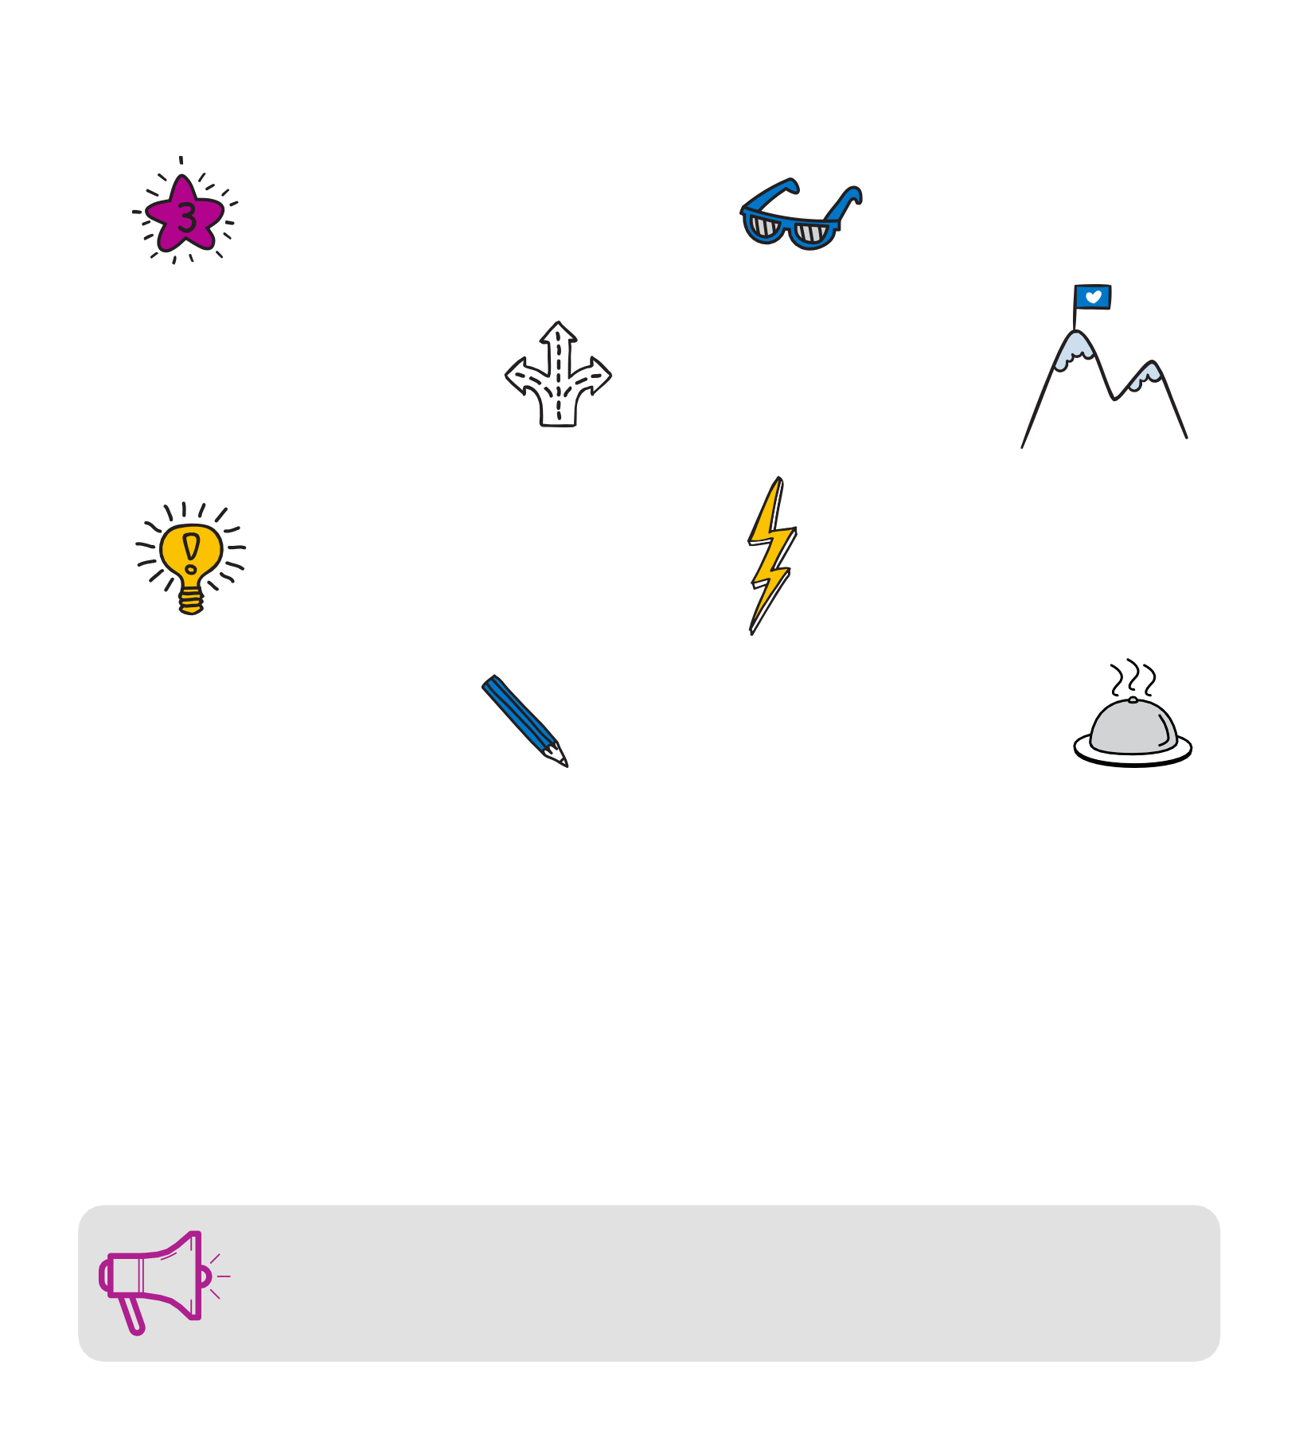

Coping strategies, like journaling, are also helpful for adults. Practicing coping strategies is a great way to take care of yourself, be more present and model healthy ways to manage stress.

For more coping skills ideas, visit Strong4Life.com/coping
hildren’s Healthcare of Atlanta Inc. All rights reserved.

