gpb.org/water-journey

Lesson Title | Develop and Use a Model of Caddisfly Communities
Timeline | 1-2 45-minute class periods

STANDARDS

4th Grade:
S4L1. Obtain, evaluate, and communicate information about the roles of organisms and the flow of energy within an ecosystem.
- Develop a model to describe the roles of producers, consumers, and decomposers in a community. (Clarification statement: Students are not expected to identify the different types of consumers – herbivores, carnivores, omnivores and
scavengers.)
- Develop simple models to illustrate the flow of energy through a food web/food chain beginning with sunlight and including producers, consumers, and decomposers.
- Design a scenario to demonstrate the effect of a change on an ecosystem. (Clarification statement: Include living and non-living factors in the scenario.)
- Use printed and digital data to develop a model illustrating and describing changes to the flow of energy in an ecosystem when plants or animals become scarce, extinct or overabundant.

Life Science:
S7L4. Obtain, evaluate, and communicate information to examine the interdependence of organisms with one another and their environments.
b. Develop a model to describe the cycling of matter and the flow of energy among biotic and abiotic components of an ecosystem.
(Clarification statement: Emphasis is on tracing movement of matter and flow of energy, not the biochemical mechanisms of photosynthesis and cellular respiration.)
c. Analyze and interpret data to provide evidence for how resource availability, disease, climate, and human activity affect individual organisms, populations, communities, and ecosystems.

MATERIALS LIST
- caddisfly larvae outline (suggested size: quarter-sheet for each student)
- pre-cut trout (suggested size: half-sheet per 3-4 students)
- glue
- leaves, sticks, pebbles, scrap craft supplies, paper to create caddisfly larvae cases, or shells
INTRODUCTION
In this simulation exercise, instructors will have students watch Georgia Public Broadcasting’s “Adopt-a-Stream” video on gpb.org/water-journey. Then, they will simulate the ecological interactions of the caddisfly larvae, water pollution, and the ecosystem in its entirety to answer the driving question:
How might one community of living things affect an ecosystem?
This simulation is appropriate for both upper elementary and middle school students.

- Small objects that can be sprinkled to represent human-made pollutants that enter the aquatic ecosystem (e.g., pepper, beads)

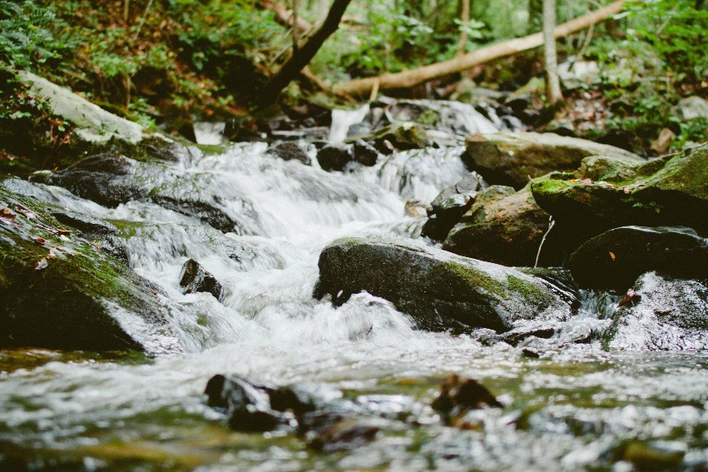
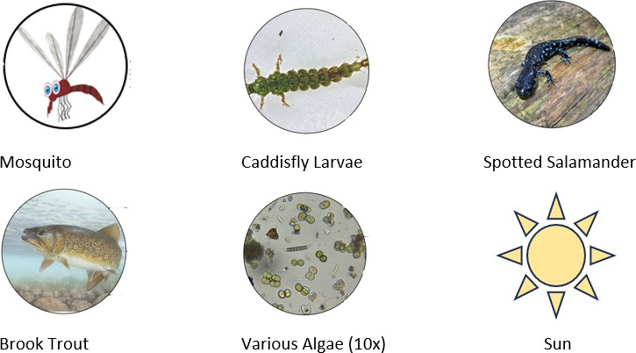
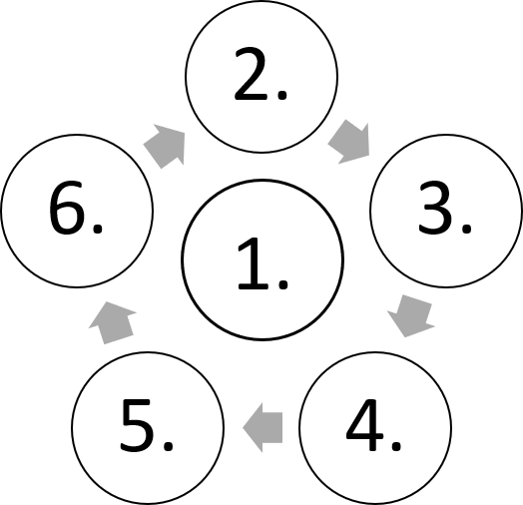
ENGAGE
Project a photograph of a nearby aquatic biome, like what is represented below. Then encourage students to think about the different types of matter and energy that flow within the biome. As students provide ideas, make a list that can be seen by the entire class. Encourage students to consider both non-living (e.g., freshwater, sunlight, rocks) and living things at various scales (e.g., algae, mosses, ferns, insect larvae, flying insects, salamanders, and trout).

Possible Photograph of Aquatic Biome
Then narrow student thinking to the images of factors shown in the student guide. Instruct students to use the common names to organize the factors based on how the matter and energy could potentially transfer in the graphic. Provide time for students to consider the relationship between the factors. Then ask guiding questions to elicit student thinking about the flow of matter and energy. Encourage student volunteers to share their flows of matter and energy transfer.
Positively reinforce students that share any differences they have in the potential flow. Emphasize that rarely does energy transfer one direction and that most organisms have multiple sources of energy. Ask students how they might modify the model of energy flow to show these potential options for energy flow (answer: add more arrows).

EXPLORE
Provide students with an outline of the caddisfly larvae to cut out. Explain to students that their objective is to simulate the ecological impact of this one species to answer the driving question, “How might one community of living things affect an ecosystem?” Explain that to be most successful at simulating real caddisfly larva they will need to first gather information about it from the passage in their student guide:
Caddisflies are a kind of insect that live in aquatic habitats like rivers and streams. In Georgia, they especially like wetlands or creeks where there is slow-moving water. Other animals, like trout, eat caddisflies and their larvae.
An important adaptation that caddisfly larvae use to protect themselves from predators is building shells or shelters out of things they find in their environment. Caddisflies are also considered an indicator species. They can tell us a lot about the health of our rivers and streams.

ELABORATE
As students gather information, encourage use of metacognitive markers. For example, students might circle language that is important, write notes and ask questions in the margin, and underline information that helps answer the driving question.

Once students have gathered relevant information, support them in using the information to build protective cases around their cut-out caddisfly larvae. Students should use the glue and leaves, sticks, scrap craft supplies, etc. to make their protective cases.

Next, situate students in small groups with their larvae around pre-cut trout. This will represent a simple ecosystem. Ask students to record their population data in the provided data table of their student guide.

Then, ask guiding questions that elicit student thinking about situations that might affect the population of the caddisfly larvae and trout. As students share ideas like predator/prey, discuss the balance between predator and prey in an ecosystem. Guide students toward stating that too few prey results in predators without enough to eat; too few predators, and the prey population reproduces beyond carrying capacity of the ecosystem. Provide explanation of carrying capacity as needed.
As students share other ideas, like pollution, ask that they predict what might occur if the caddisfly larvae were exposed to a pollutant. Students should record their thinking in the student guide. Discourage answers like, “They will all die.” Encourage responses like, “The caddisfly larvae might eat the pollutant. Then maybe the trout eats the caddisfly larvae.
Now the trout has the pollutant and they’ll both die.”

Next, sprinkle pepper or beads over the larvae to represent pollution. Ask guiding questions that elicit students’ thinking about different types of pollution in water (e.g., oil, fertilizer or feces, sewer overflows, litter, etc.). Now that the simple ecosystem is being affected by pollution, some larvae die but some are still eaten by the trout. Simulate the effects by taking away larvae from different groups. Organize the larvae by those that had been eaten and those that died from exposure to the pollutant. Ask students to record the new population data in their data table of their student guide.

Then, tell students that some of the trout die because they ate caddisfly larvae that had been exposed to pollution. Explain that this is referred to as bioaccumulation. Provide additional examples as needed to support student understanding.
Remove a trout to simulate its death.

Explain that other trout are also dying because they don’t have enough to eat, so remove another trout. Continue the simulation until there are no fish left. As simulated time passes, remind students to record population data in their data tables.

EXPLAIN
As caddisfly larvae die due to pollution and predators like trout, the trout will also begin to die. Meanwhile bacteria, fungi, or algae that the larvae usually eat will start to increase.

As students begin to engage in sense making about all the ecological impacts of pollution in the aquatic biome, direct them to record their thinking in the graphic organizer in their student guide:

Effect
Describe the phenomena. Use data from your simulation as part of your description.
Mechanisms
What are the processes that connect the causes to the effect/ phenomena?
Cause(s)

Possible Answer Key:
Effect
Communities of caddisfly larvae and trout died, while communities of algae flourished.
Caddifly larvae population began at 10 and decreased to 0 over time. Meanwhile, the algae population tripled in size, forming a colony that was visible without the use of a microscope.
Mechanisms
bioaccumulation
Cause(s)
predator-prey
relationships

Once students get their ideas organized in the graphic, you may want to support students in a final written explanation of how the simulation models the cause-and-effect outcomes of a pollutant entering an ecosystem.

ELABORATE
Facilitate discussion about what students can do to help keep streams and rivers healthy. Some of the simplest ways are to pick up litter, clean up after pets, and prevent chemicals like soaps or oils from spilling. Visit cleanwatercampaign.org for more ideas.

