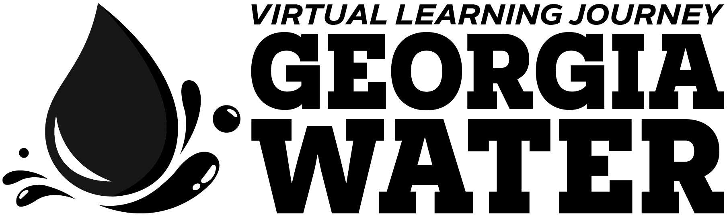

gpb.org/water-journey

Lesson Title | Be A Water Detective
Timeline | 1-2 45-minute class periods
STANDARDS
Earth Science:
S6E6. Obtain, evaluate, and communicate information about the uses and conservation of various natural resources and how they impact the Earth.
b. Design and evaluate solutions for sustaining the quality and supply of natural resources such as water, soil, and air.
MATERIALS LIST
- pen or pencil
- student guide
- food dye
- timer or stopwatch
- calculator
INTRODUCTION
In Georgia, water keeps the state’s industries going, especially the agricultural industry. Much of Georgia’s farms and orchards are in the southern part of the state, whereas the metro Atlanta area is further north. Georgia’s agriculture is dependent on water that comes from upstream, so it’s important for people in North Georgia to use water resources wisely to ensure a clean, abundant water supply for our farms. This activity will help students understand how much water they use each day and think about the ways they can reduce the amount of water they use.
Prior to this investigation of personal water usage, instructors should have students watch the “Importance of Water in Agriculture” video from Georgia Public Broadcasting’s Georgia’s Water Virtual Learning Journey. The video can be found at gpb.org/water-journey. This activity is for middle school students but can be adapted for younger children.
ENGAGE
Project the image below (also included in the student guide) to elicit student thinking about their current water usage. Provide calculators as needed as students predict/ calculate their weekly water usage. Then facilitate an initial discussion with the guiding questions: How do you think your water usage compares to the average person? Are there ways you might be able to reduce your water usage? Provide time for students to record their thoughts on the student guide.
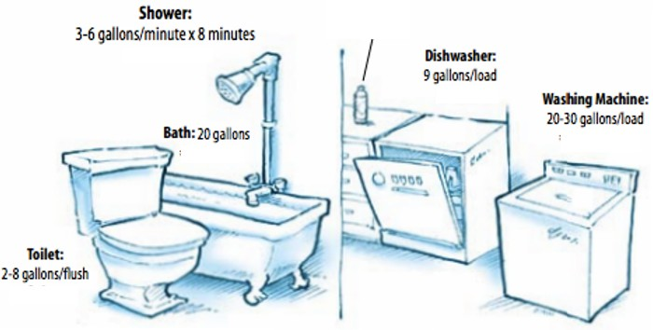

EXPLORE
Make explicit that students will (a) now carry out an investigation into their exact water usage, (b) that the purpose of this personal water investigation is to see how closely it aligns with their perceived water usage, and (c) consider ways to reduce water usage.

Read aloud the instructions for collecting personal water usage data (see below and in student guide). Provide time for students to ask clarifying questions.

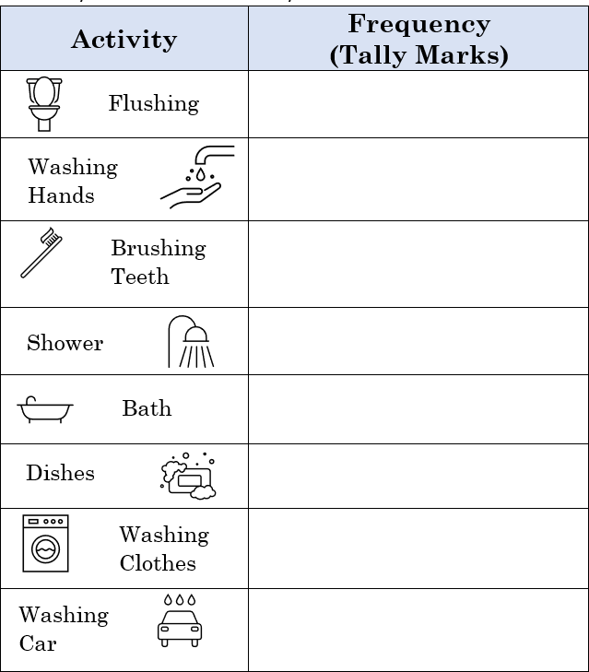
PART 1
- Observe and record your actual daily water use in the data table.
  - Mark a tally for when you flush the toilet, turn on the sink to brush your teeth or wash your hands, do dishes, take a bath or shower, water the garden, cook, or clean up.
  - If you (or your parents) did additional water activities for you, like wash your clothes, car, or something else, make sure to mark that down.
- Continue to track your water use for 3-5 days.

PART 2
After each day of data collection, consider a way to include daily check-ins with students (e.g., warm up).

- Check your home for leaks.
- The most common household leak comes from the toilet, so check that first.
- Lift the lid off the toilet tank. Drop 5-6 drops of a colored food dye into the tank. Replace the lid.
- Set a timer for 10 minutes.
- Check the bowl of the toilet. If you observe dye in the bowl, then the toilet has a leak.
- If you live in a home, locate your water meter. It is usually at front of the house towards the street.
- Check the number on the meter. Write it down.
- Set a timer for two hours and do not use any water during that time.
- If the number changes, then you have a leak in the house.

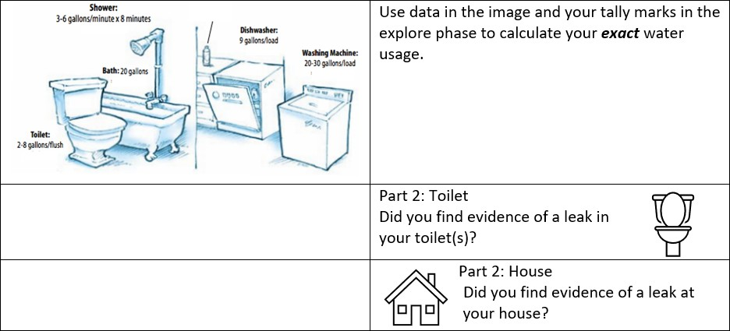
EXPLAIN
After 3-5 days of data collection, regroup the class of students to analyze and interpret the data. As students use the prompts on the student guide to direct their data analysis (see below and student guide), provide time and support as needed.

ESSENTIAL QUESTIONS
Once analysis is completed, use the following questions as initial prompts to facilitate discussion:
- How are you most often using water? (Include way and gallon usage.)
- How close were your predictions to your actual water usage?
- What do you think explains the differences?
SUMMARY
Provide time for students to individually read the new information below (also on student guide). Then read aloud or have a student volunteer read aloud the information as well.
In Georgia, water keeps the state’s industries going, especially the agricultural industry. Much of Georgia’s farms and orchards are in the southern part of the state, whereas the metro Atlanta area is further north. Georgia’s agriculture is dependent on water that comes from upstream, so it’s important for people in North Georgia to use water resources wisely to ensure a clean, abundant water supply for our farms.
ELABORATE
Check student comprehension with questions like:
- What industry relies heavily on water?
- Where are most farms and orchards located?
- How do these locations compare to where we/you live?
- Where does the water for these farms originate?
- How does this lead to a call for action for us/you?
After discussion, provide time for students to summarize their learning (see prompts on student guide).
Possible Modifications:
If you and your students want to do a deeper dive and some harder calculations, input your data into the My Drop Counts Water Use Calculator. How many gallons can your students pledge to save through the My Drop Counts pledge?

