Name: Date:

gpb.org/water-journey

Student Guide: Be a Water Detective

Engage: How much water do you think you use? Use data from the image to approximate the amount of water you use each week.
Learning Targets: I can...
- plan and carry out an investigation into
my personal water use.
- analyze and interpret data about my personal water use.
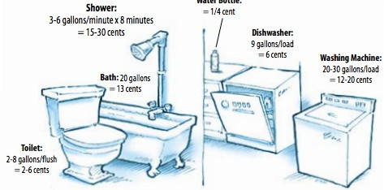
Show your calculations.

Source of Water | Daily (gallons) | Weekly (gallons) | Total (gallons)
Toilet
Bath/Shower
Dishwasher
Washing Machine
Other

INITIAL THINKING
How do you think your water usage compares to the average person? Are there ways you might be able to reduce your water usage? (Please write your response in complete sentences.)

EXPLORE
Carry out an investigation into your exact water usage.

PART 1
- Observe and record your actual daily water use in the data table below.
  - Mark a tally for when you flush the toilet, turn on the sink to brush your teeth or wash your hands, do dishes, take a bath or shower, water the garden, cook, or clean up.
  - If you (or your parents) did additional water activities for you, like wash your clothes, car, or something else, make sure to mark that down.
- Continue to track your water use for 3-5 days.

Activity | Frequency (Tally Marks)
Flushing
Washing Hands
Brushing Teeth
Shower
Bath
Dishes
Washing Clothes
Washing Car

PART 2
- Check your home for leaks.
- The most common household leak comes from the toilet, so check that first.
- Lift the lid off the toilet tank. Drop 5-6 drops of a colored food dye into the tank. Replace the lid.
- Set a timer for 10 minutes.
- Check the bowl of the toilet. If you observe dye in the bowl, then the toilet has a leak.
- If you live in a home, locate your water meter, usually at front of the house towards the street.
- Check the number on the meter. Write it down.
- Set a timer for two hours and do not use any water during that time.
- If the number changes, then you have a leak in the house.

EXPLAIN
Analyze the exact water usage data from the exploration.

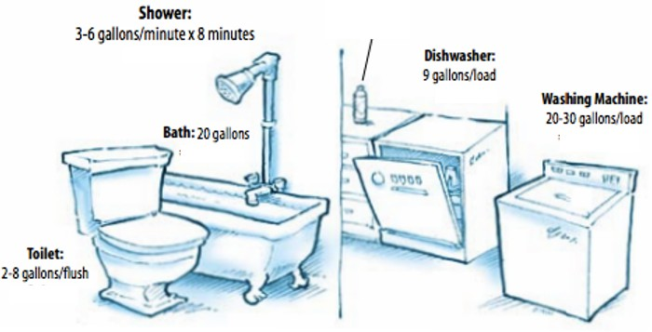 | Use data in the image and your tally marks in the explore phase to calculate your exact water usage.
Part 2: Toilet
Did you find evidence of a leak in your toilet(s)?
Part 2: House
Did you find evidence of a leak at your house?

Interpret the data to make decisions about how to decrease your water usage.

  - How are you most often using water? (Include way and gallon usage.)

  - Compare your actual water usage to your predictions. How close were your predictions to your actual water usage? What do you think explains the differences?

In Georgia, water keeps the state’s industries going, especially the agricultural industry. Much of Georgia’s farms and orchards are in the southern part of the state, whereas the metro Atlanta area is further north. Georgia’s agriculture is dependent on water that comes from upstream, so it’s important for people in North Georgia to use water resources wisely to ensure a clean, abundant water supply for our farms.

- Where is there potential for you to decrease water use?

- Why is it important for you to consider ways to decrease water use?

