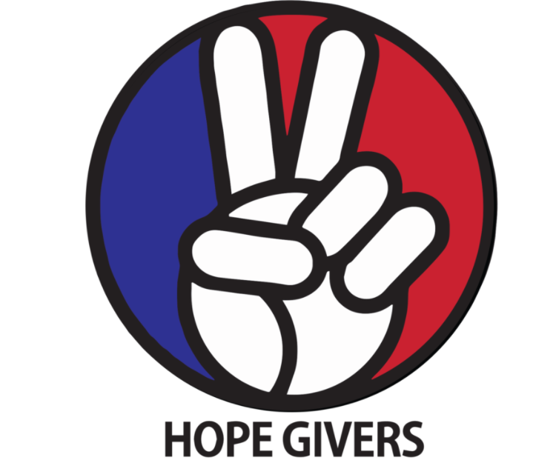
Hope Givers Season 2 Episode: 3
Grades: 7th-12th

What Should Kids Get Out Of It?
Students should be able to understand what inclusion means and examples where there is and is not inclusion. Students should reflect on situations in their life where they witnessed inclusion and felt included themselves. They should also be able to identify situations in their lives where they witnessed or experienced something where there was a lack of inclusion. How can students push through those barriers or help others do the same? How can self care help people push through obstacles in their lives? Students should also be able to practice self care using techniques that focus on mental, physical, and emotional health.

Hope Givers Video Summary
Inclusion. In episode 3 we learn about a Mexican female astronaut(Katya) that became the first mexican born woman in space. Her journey was not easy as she had to overcome barriers in many areas of her life as she worked towards her goal of going into space. In the Youth Across America student film segment we meet a young girl(Giselle) who was battling depression and felt disconnected from her peers and community. She began practicing self care and focusing on improving herself which helped her overcome some of those challenges in life. This pairs with Katya who also used self care to overcome some of the challenges in her life.

Standards Alignment
National HE Standards:

Standard 1: Students will comprehend concepts related to health promotion and disease prevention to enhance health.

Standard 2: Students will analyze the influence of family, peers, culture, media, technology, and other factors on health behaviors.

Standard 3: Students will demonstrate the ability to access valid information and products and services to enhance health.

Standard 4: Students will demonstrate the ability to use interpersonal communication skills to enhance health and avoid or reduce health risks.

Standard 5: Students will demonstrate the ability to use decision-making skills to enhance health.

Standard 6: Students will demonstrate the ability to use goal-setting skills to enhance health.

Standard 7: Students will demonstrate the ability to practice health-enhancing behaviors and avoid or reduce health risks.

Standard 8: Students will demonstrate the ability to advocate for personal, family, and community health.

Georgia HE Standards:

HEHS.1.c: Analyze how the environment and personal health are interrelated.

HEHS.1.g: Compare and contrast the benefits of and barriers to practicing a variety of healthy behaviors.

HEHS.2.a: Analyze how the family, culture, and environment influence the health of individuals.

HEHS.3.b: Investigate the accessibility of products and services that enhance health

HEHS.6.c: Analyze barriers and solutions to achieving health goals.

HEHS.6.d: Monitor progress in achieving short term and long-term personal health goals.

HEHS.7.b: Choose and implement a variety of healthy practices and behaviors that will consistently maintain or improve health.

HEHS.8.b: Demonstrate how to treat all individuals with respect and dignity. Learning how to appropriately disagree with others is a valued skill set.

NOTE: Standards are listed for High School Health in Georgia. Content may be used in middle school and standards listed may be changed to fit the needs of a middle school lesson plan. Please refer to the GSE for appropriate middle school standards. Content may also be used in other states and standards may be changed to fit those needs. Please refer to your own state standards for appropriate standards for your lesson plans.

Classroom Instruction
What is the main goal? Students should know what inclusion means and situations they can make others feel more included. They should understand how a lack of inclusion may make people feel and realize how they may feel if they were not included in something based on factors they cannot control.

Materials I need: Technology (To show the video), handouts as needed or an online version of some or all of the handouts (If you are paperless) Optional PE or game equipment for activity 4.

What do the kids need to do? Watch the video, Complete some or all of the handouts/activities, Participate in discussions, Practice self care techniques. Yes, it's that easy!

What do I need to do? Show the video to the class, lead discussions as needed, Have students complete some or all of the handouts, Lead self care techniques in small or large groups. And yes, it really is that easy!

Lesson Introduction: Students should find a space in the classroom, or outside if needed, that they can comfortably move around. Have students do a few stretches while listening to music. They can practice yoga stretches/movements. Do this for 5-10 minutes. Afterwards, have students discuss the positive benefits of relaxing and practicing yoga or just stretching. How did the music help? The music can be individually but it is recommended the teacher play the music for the whole class.

Classroom Activities:
What is Inclusion?
How Would I Feel?
Depression: What is it and How does it affect me?
Games and Adjustments
Goal Setting: Hope and Dreams Activity

Lesson Closure: What I love about you. Have each student get a piece of paper and write their name at the top center. On the top line, have them write: What I love about you. Next, have the students pass their paper to someone else. Each student will write one or more things they love about that person. Set a timer and give 30 seconds for each person. Have them continue to pass the paper around and rotate every 30 seconds until the time ends. Time will depend on how long you have to complete this activity. Once the final time is up, have each person pass the paper back to the correct person and let them read what others wrote about them. Each student should write at least one thing on each paper. They cannot pass or skip.

How Do Teachers Know The Kids Are Successful?
At the end of this lesson, students should be able to practice inclusion and understand what inclusion means. Students should identify different situations where there is a lack of inclusion and situations where there is plenty of inclusion present. Students should also know how they can help include more people in a variety of different situations.

How Do The Kids Know They Are Successful?
At the end of this lesson, students should be able to practice inclusion through understanding, kindness, thoughtfulness, and inclusiveness. Students should help others when possible through a variety of techniques. They should also think about how others feel and practice empathy.

Differentiation and Extension of Learning
Ideas for Differentiation:
Provide written material in languages other than English.
Incorporate different communities in your instruction. Ask students to share how they may think about a topic differently to pull information from various sources.
Provide students with both written material and visual material.
Break down work into smaller portions for students with accommodations.
Utilize small group time to provide more one on one instruction for students who need extended learning.
Pass out handouts/guided notes as needed for students.

Opportunities for Extension:

Inclusion Activities
Reach Out Campaign

Additional Resources
National Health Standards, Georgia Health Standards of Excellence, HECAT

Attachments:
What is Inclusion?

Students should answer the following questions in the space provided. The teacher will ask students to share their answers with the class.

What is the textbook definition of inclusion? _____________________________________________________

__________________________________________________________________________________________

__________________________________________________________________________________________

What does inclusion mean to me? How is my definition different from the textbook definition? _____________

__________________________________________________________________________________________

__________________________________________________________________________________________

__________________________________________________________________________________________

Using your technology, research three companies or groups that practice really good inclusion. How do they accomplish this? What are some of the techniques they use? What are the benefits of including a variety of people?

How Would I Feel?

The students should write and describe 1-3 situations where they have not felt included and answer the following questions in the form of a journal entry or online submission.(Teacher discretion on how many to complete) If they cannot think of enough items, have the students think of a situation where they would not feel included if that actually happened to them.

Description of the activity:

Why did you not feel included?

How did it make you feel to not feel included in the group or situation?

Is there anything you could have done differently to help the situation?

What do you wish the other people had done to make you feel more included?

Depression: What is it and How does it affect me?

Students should make small groups of 3-4 people. This can be changed depending on class sizes. Next, the students will discuss and share with the group the following questions and answers. Have them think about each answer individually and what it means to them personally.

- What is depression?
- How many students in the group know someone personally that battles depression?
- What are a few situations that may make depression worse or trigger depression? Think of a few that are short term(Death in the family for example) and some that are long term(Work stress)
- What can help people cope with different situations? (Examples: Talking with friends, counselors)
- Research contact information for the National Suicide Prevention Hotline. Students may choose to save this information in their phone.

After students have shared their answers with the group, have them come up with one answer per question as a group to share with the whole class. Students will then compare and may discuss the group answers as a whole class.

Games and Adjustments

The teacher should plan a few activities that require students to practice a skill. Examples include throw and catch a ball, horseshoes, frisbee throw or other activities. Utilize an outdoor space such as a football field, outdoor grass area or the gym if the weather dictates.

Students should be placed in random groups. Tell the students they will participate in each activity and need to think about ways they can modify the activities for other students.

Take the class to your designated area and play the different activities for 5-10 minutes at each station/activity. Students should first share how the activity should be modified for them. For example: If the group is tossing a football and some students can throw it really far and some cannot throw very far at all, the group should stay close to each other so all students can participate.

Rotate and complete the activities until the time limit.

After all groups have completed all of the activities, have them think about how they felt being included. Share their answer with the group or this can be completed as a whole class.

Have students answer the following questions as a follow up.

- How does inclusion help everyone in the group?
- How did you feel helping other students feel included?
- How did you feel if you felt like you were being included in the group/activities?
- If someone is feeling sad or down, how can you help them feel better by including them in activities or friend groups?

GOAL SETTING ACTIVITY
Teacher Instructions

This lesson may pair with the current video or other goal setting lessons you have in your classroom. This can also be a simple activity to generate thought with the students about the goals they have in life or a larger, more in depth activity about goal setting.

For the purpose of this activity, it will be short and concise. We want the students to think about goals they may have and possible hurdles they may encounter. Students should think about the path they want to be on in order to reach their goals. Teachers should pair in points of emphasis from the video and other lessons from this unit.

An extension activity suggestion is to use this as an opening to a larger lesson plan or unit plan on goal setting. This could also be used as a pre assessment.

GOAL SETTING ACTIVITY
Students should answer the following questions and use the answers on a vision board.

What is one goal you have in life? Play sports, entrepreneurship, the arts, have a family?

What is the focus of your goal? Is it math/science, sports, construction/engineering, the arts etc.?

What do you want to get out of it? To be famous, make money, live happy, be comfortable?

What do you need to do in order to reach your goal? Think both big and small. Do you need a college degree? Do you need to practice daily to get good at a skill? Do you need help? How much will it cost? How long will it take?

Next, create a vision board. Place 10 pictures on your board using your answers from above as a guide. Next, write 10 things on your board. These can be short sentences, words etc. using your answers from above as a guide.

EXAMPLE:

