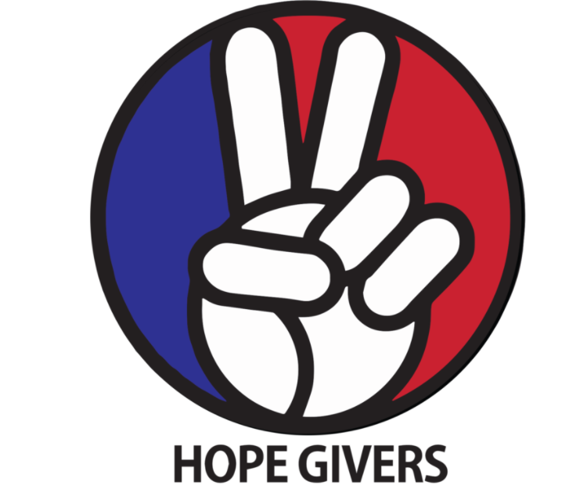
Hope Givers Season 2 Episode: 2
Grades: 7th-12th
What Should Kids Get Out Of It?
Students should be able to identify and recognize bullying and understand how they can manage situations and people who bully. Students should be able to identify and utilize trusted adults within the school or community. What are the benefits of using a trusted adult to help you? What are some reasons people bully other people? How can you manage a bully? Students should also be able to practice self care using techniques that focus on mental, physical, and emotional health.

Hope Givers Video Summary
Bullying and Trusted Adult. In this episode you meet a musician(Avery Dixon) who overcame bullying through his passion and love for music. He participated on the hit show ‘America's Got Talent’ and became well known for his story and talent. This video highlights bullying and trusted adults. It also highlights using music to overcome low points in our lives and to help us move forward.

Standards Alignment
National HE Standards:

Standard 1: Students will comprehend concepts related to health promotion and disease prevention to enhance health.

Standard 2: Students will analyze the influence of family, peers, culture, media, technology, and other factors on health behaviors.

Standard 3: Students will demonstrate the ability to access valid information and products and services to enhance health.

Standard 4: Students will demonstrate the ability to use interpersonal communication skills to enhance health and avoid or reduce health risks.

Standard 5: Students will demonstrate the ability to use decision-making skills to enhance health.

Standard 6: Students will demonstrate the ability to use goal-setting skills to enhance health.

Standard 7: Students will demonstrate the ability to practice health-enhancing behaviors and avoid or reduce health risks.

Standard 8: Students will demonstrate the ability to advocate for personal, family, and community health.

Georgia HE Standards:

HEHS.1.c: Analyze how the environment and personal health are interrelated.

HEHS.1.n: Describe the interrelationships of emotional, intellectual, physical, and social health.

HEHS.2.a: Analyze how the family, culture, and environment influence the health of individuals.

HEHS.2.d: Evaluate how the school and community can affect personal health practices and behavior

HEHS.4.b: Demonstrate strategies to prevent, manage, or resolve conflicts without harming self or others.

HEHS.4.c: Demonstrate how to ask for and offer assistance to enhance the health of self and others.

HEHS.7.a: Demonstrate individual responsibility for improving personal health.

HEHS.8.e: Demonstrate how to treat all individuals with respect and dignity. Learning how to appropriately disagree with others is a valued skill set

NOTE: Standards are listed for High School Health in Georgia. Content may be used in middle school and standards listed may be changed to fit the needs of a middle school lesson plan. Please refer to the GSE for appropriate middle school standards. Content may also be used in other states and standards may be changed to fit those needs. Please refer to your own state standards for appropriate standards for your lesson plans.

Classroom Instruction
What is the main goal? Students should practice kindness and understand what bullying is and ways to avoid it. Students need to identify trusted adults they can confide in for help or advice. Students should also recognize ways they can help others who are being bullied.

Materials I need: Technology (To show the video), handouts as needed or an online version of some or all of the handouts (If you are paperless)

What do the kids need to do? Watch the video, Complete some or all of the handouts/activities, Participate in discussions, Practice self care techniques. Yes, it's that easy!

What do I need to do? Show the video to the class, lead discussions as needed, Have students complete some or all of the handouts, Lead self care techniques in small or large groups. And yes, it really is that easy!

Lesson Introduction: Ask students to raise their hand if they have been bullied and/or know of a close friend who has been bullied. Chances are, most students have experienced bullying first hand at some point in their life. Ask students to share their experiences with the class if they feel comfortable. This can lead to great discussion about bullying

Classroom Activities:
What is a Bully?
How can bullying affect me?
Trusted Adults Activity
Stand up to Bullying Campaign

Lesson Closure:
Classroom Karaoke. Students can choose one or two songs to play out loud. Students can sing along to the music or simply listen to it. You may choose to end after the song or have it lead to a short discussion about how music can make people feel better. Why is that? Are certain songs or music genres better to listen to in order to make us feel better? Why or why not?

Discuss the importance of music and its impact on our mental health. This may be a lesson closure or can blend in to other lessons/activities.

How Do Teachers Know The Kids Are Successful?
At the end of this lesson, students will be able to understand what a bully is and how it affects people physically, mentally, and emotionally. Students should identify a trusted adult in their lives and people they can go to for help, advice, or simply someone to listen to them. They also should identify ways to avoid bullies or get help dealing with a bully.

How Do The Kids Know They Are Successful?
At the end of this lesson, students should be able to identify and utilize at least one trusted adult in their lives. Students should feel comfortable expressing themselves and their concerns to other people. Students should be able to practice self care and be kind to other people by demonstrating positive qualities such as respect and understanding.

Differentiation and Extension of Learning
Ideas for Differentiation:
Provide written material in languages other than English.
Incorporate different communities in your instruction. Ask students to share how they may think about a topic differently to pull information from various sources.
Provide students with both written material and visual material.
Break down work into smaller portions for students with accommodations.
Utilize small group time to provide more one on one instruction for students who need extended learning.
Pass out handouts/guided notes as needed for students.

Opportunities for Extension:

Trusted adult activities
Be Nice Campaign
Anti Bullying Video Announcements(Play on school TV, Morning shows etc)

Additional Resources
National Health Standards, Georgia Health Standards of Excellence, HECAT

Attachments:
What is a Bully?

Students should answer the following questions in a journal, online response or other submission form:

- What is a bully to you?
- How do you define bullying?
- Is bullying different than or the same as picking on someone? Justify your answer.
- Provide three examples of how someone can bully another person.
- What age group do you feel has the most bullying occurring in it? Why do you feel that way?
- Why do you feel bullying is so common in society today?
- What are some reasons you think bullying is not reported as much as it should be? If you did not report bullying to the proper person/people, How does that justify the bullying?
- Some people think that if they report bullying they witness, they are ‘snitching’ on them. What would you say to that person who feels that way to help them understand the importance of reporting bullying?

How Can Bullying Affect Me?

Write a short story about a situation where a young person could be bullied or picked on in the space provided.

If I were in that person's shoes, how would I feel:

Physically

Mentally

Emotionally

Write another short story about a situation where a young person could be bullied or picked on in the space provided.

If I were in that person's shoes, how would I feel:

Physically

Mentally

Emotionally

Trusted Adults Activity

In the spaces provided, answer the questions and then complete the final activity.

Do you have a trusted adult in your life outside of your family? ______________________________________

Who is that trusted adult?_____________________________________________________________________

What qualities does that person have that makes you comfortable to share with them or go to them for help or advice?
__________________________________________________________________________________________

__________________________________________________________________________________________

__________________________________________________________________________________________

How could you help a friend who does not have a trusted adult in their life?_____________________________

__________________________________________________________________________________________

__________________________________________________________________________________________

__________________________________________________________________________________________

Have you had someone in your life that you felt was NOT a good trusted adult? What did they do or not do that made you feel that way? Do NOT put a name in this section.

__________________________________________________________________________________________

__________________________________________________________________________________________

__________________________________________________________________________________________

Next, complete the following activity.

Write a letter to your trusted adult or make a card for them. Thank them for being a trusted adult, tell them what you appreciate about them and why you feel comfortable confiding in them. One to two paragraphs is plenty.

Deliver that card or letter to them personally or mail it to them if they do not live close enough to you.

“Be Kind.” Anti-bullying Campaign

For the teacher:

Assign groups of 3-4 people. You can change this depending on class size or other factors.

Have students create PSA’s, poster boards or signs to hang around the school.

The theme: BE KIND.

Students should design a poster however they feel, using clip art, drawings, paintings, computer generated designs or other designs.

You can set different requirements. For example: It should contain at least ten words that relate to kindness or anti-bullying. It must have three pictures or more on it.

Once students have completed and turned in their poster, you can take the whole class around the school during their class period to hang them up. Be sure to have permission on where they can be hung or not hung.

