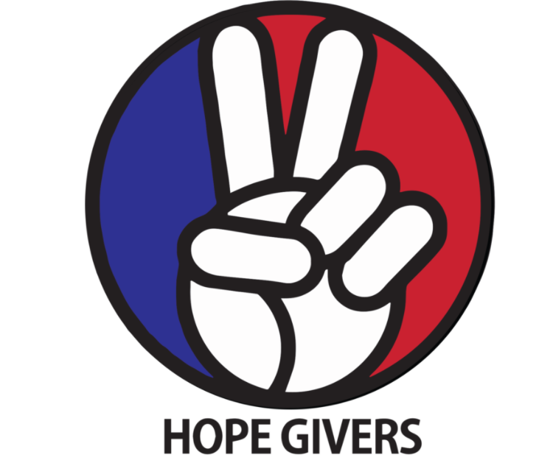
Hope Givers Season 2 Episode: 1
Grades: 7th-12th

What Should Kids Get Out Of It?
Students should be able to not only define what a disability is but how they can overcome them. The focus of the video is ‘Disability does not mean inability’. Students should focus on that statement and reflect on what that means to them. How can they overcome challenges in their lives? What positive qualities will help them overcome those challenges? Students should also be able to practice self care using techniques that focus on mental, physical, and emotional health.

Hope Givers Video Summary
Disability: Episode 1 focuses on students who have disabilities and how they do not let those disabilities define who they are or what they are capable of. You meet an artist(Tyler) who was born deaf that produces amazing paintings for many famous people including NBA players and Vice Presidents. He faced bullying growing up for his speech impediment. The Youth Across America segment focuses on a student who has no legs and has to navigate life and many challenges adapting and overcoming that disability.

Standards Alignment
National HE Standards:

Standard 1: Students will comprehend concepts related to health promotion and disease prevention to enhance health.

Standard 2: Students will analyze the influence of family, peers, culture, media, technology, and other factors on health behaviors.

Standard 3: Students will demonstrate the ability to access valid information and products and services to enhance health.

Standard 4: Students will demonstrate the ability to use interpersonal communication skills to enhance health and avoid or reduce health risks.

Standard 5: Students will demonstrate the ability to use decision-making skills to enhance health.

Standard 6: Students will demonstrate the ability to use goal-setting skills to enhance health.

Standard 7: Students will demonstrate the ability to practice health-enhancing behaviors and avoid or reduce health risks.

Standard 8: Students will demonstrate the ability to advocate for personal, family, and community health.

Georgia HE Standards:

HEHS.1.k: Describe the interrelationship of having a traumatic physical injury on a person’s social and emotional health.

HEHS.1.n: Describe the interrelationships of emotional, intellectual, physical, and social health

HEHS.7.a: Demonstrate individual responsibility for improving personal health.

HEHS.7.b: Choose and implement a variety of healthy practices and behaviors that will consistently maintain or improve health.

HEHS.8.e: Demonstrate how to treat all individuals with respect and dignity. Learning how to appropriately disagree with others is a valued skill set.

NOTE: Standards are listed for High School Health in Georgia. Content may be used in middle school and standards listed may be changed to fit the needs of a middle school lesson plan. Please refer to the GSE for appropriate middle school standards. Content may also be used in other states and standards may be changed to fit those needs. Please refer to your own state standards for appropriate standards for your lesson plans.

Classroom Instruction
What is the main goal? The main goal of this lesson is for students to practice working through challenges and to be successful in a variety of ways. Do students have disabilities? How does that define them? And if students say no, they do not have disabilities, they can think of a challenge they have had where they had to work really hard to achieve something or they did not achieve it. Why did they not?

Materials I need: Technology (To show the video), handouts as needed or an online version of some or all of the handouts (If you are paperless)

What do the kids need to do? Watch the video, Complete some or all of the handouts/activities, Participate in discussions, Practice self care techniques. Yes, it's that easy!

What do I need to do? Show the video to the class, lead discussions as needed, Have students complete some or all of the handouts, Lead self care techniques in small or large groups. And yes, it really is that easy!

Lesson Introduction: The teacher should ask students to think about a disability. Any will do. Now, students should write about how they would feel if they had that disability. Write down their answers. For example: If you have an athlete in the room, have them think about what their life would be like if they could not participate in that sport. How would they feel? Have students share with the class if they feel comfortable with their answer.

Classroom Activities:
Journal Entries
Roundtable Discussions
Reflection Questions
Interview Questions
What is a Disability? Worksheet

Lesson Closure:
Students will give song suggestions that are relaxing, happy, or fun in nature. Play one or two songs and you can have students close their eyes, put their heads down, or simply relax as they feel comfortable to. This pairs with the Lesson 1 relaxation technique from the video.

How Do Teachers Know The Kids Are Successful?
At the end of this lesson, students will be able to:
Identify what a disability is.
Identify and overcome challenges in their lives.
Practice skills that help students overcome challenges.
Practice self care.

How Do The Kids Know They Are Successful?
At the end of this lesson, students will know how to:
Practice self care.
Feel better equipped to take on challenges in their lives.
Identify challenges in their lives and feel confident they can work towards overcoming those challenges.
Be more positive about disabilities they may have or areas they may struggle with

Differentiation and Extension of Learning
Ideas for Differentiation:
Provide written material in languages other than English.
Incorporate different communities in your instruction. Ask students to share how they may think about a topic differently to pull information from various sources.
Provide students with both written material and visual material.
Break down work into smaller portions for students with accommodations.
Utilize small group time to provide more one on one instruction for students who need extended learning.
Pass out handouts/guided notes as needed for students.

Opportunities for Extension:
Help other students overcome their disabilities.
Volunteer at a facility that works with people with disabilities.
Create PSA’s about disabilities using the theme ‘Disability is not Inability’
Overcoming Challenges Activity or Worksheet

Additional Resources
National Health Standards, Georgia Health Standards of Excellence, HECAT

Journal Entries

Students can answer some or all of the following questions in a self journal or their health binder/book. Teachers can assign questions or let students choose a certain amount on their own.

- What do you think a disability is?
- Do you know someone who has a disability?
- How can you work through a disability or weakness?
- How does a positive mindset help you overcome challenges in your life?
- What are resources someone can use to help with a disability? Think national and also some specific to your community.
- What are some barriers someone with a disability may face in life?
- How can you help someone with a disability?

Roundtable Discussions

Below is a list of some sample discussion talking points. The teacher can use some or all of these to stimulate small or large group discussions. This can be teacher or student led and the teacher should help only as needed to further discussion or prompt ideas.

- What are some things that can be more difficult in life if you had a disability?
- What is something you really enjoy doing? How would you feel if you could not practice/do that activity?
- What strengths do people with disabilities have that you feel you can learn from?
- Put yourself in someone else's shoes who has a disability. Think of different activities. How would your life change? How would you feel? Have them think of different disabilities(Such as being blind, deaf, loss of a limb etc.)
- Besides a disability, what are some weaknesses you have? How is that similar to and different from a disability? How do you overcome challenges associated with your weakness? How can those things help with either a disability or weakness? (Example: Staying positive can help both because a positive mindset is important to overcome any hurdle in your life)

Have students share their answers in either a small group or with the class. You can have several students share or the entire class if time permits. The teacher can also use the discussion to prompt further questions relating to answer given by the students.

Reflection Questions

The following list contains ideas that students can practice and then reflect on that practice. Students can be assigned one or two or the whole list to complete. Students should complete the task and then answer the related reflection questions. Students can also choose one or two to complete on their own. Students can also choose one of the three and complete it more than once.

TASK: During the school day, help a student who has a disability by doing something nice for them. Carry a bookbag, pack up during an activity, play with them during PE or recess or anything else that may help them. Answer the following questions after you complete the task.

- What did you do to help them?
- How did it make you feel?
- How did the task help them?
- How did it make them feel?

TASK: Ask a student with a disability to interview them if they are comfortable with that. Ask them what their disability is and how it affects them. What are some challenges they face due to their disability? How does it make them feel? What are things they do to overcome challenges related to their disability? Is there anything they wish other people knew about them or their disability? What is something they wish other people would do or not do regarding them or their disability? Record their answers.

TASK: Ask a student for an interview about a weakness they have. Ask them the following questions and record their answers:
What is a weakness you have? How does it impact you?
What are some things you do to help overcome challenges associated with your weakness?
How can other people help you if you wanted help?

Interview Questions

Students should interview a parent, guardian, or trusted adult in their life and ask the following questions. Students should record their answers. You can also assign some or most of the questions or you can have them come up with some of their own questions to ask.

- Who is the person you are interviewing?
- What is their relation to you?
- What is something you struggled with growing up? A weakness you had.
- Did you overcome that weakness?
- What did you do to overcome that weakness?
- Did it work? Why or why not?
- Would you do anything differently in today's world to overcome that weakness? Think of new techniques, treatments, medicine, technology etc.
- How did that weakness impact your mental or physical health?
- Did you have anyone help you? If so, what did they do to help you?

What is a Disability?

Students should record their answers in the space provided.

What is a disability? _________________________________________________________________________

__________________________________________________________________________________________

__________________________________________________________________________________________

What are five examples of a disability? __________________________________________________________

__________________________________________________________________________________________

What are five community resources that would help someone with a disability?__________________________

__________________________________________________________________________________________

__________________________________________________________________________________________

What are 10 personal qualities or traits that would help someone overcome a disability?___________________

_________________________________________________________________________________________

_________________________________________________________________________________________

_________________________________________________________________________________________

What are three things you can do to be an advocate for people with disabilities?_________________________

_________________________________________________________________________________________

_________________________________________________________________________________________

_________________________________________________________________________________________

Advocacy Extension:

After students complete the ‘What is a Disability' worksheet, have them complete the activities they recorded for their answer about advocacy.

For example: If a student wrote they can write a letter to their political representative about adding more laws to help students with disabilities, they can actually write that letter and send it to their representative.

If a student said they can form a student-led advocacy group that promotes students with disabilities and how they are treated, they can form that group and hold monthly meetings with administration about those things.

You can also assign teacher designated activities such as writing a letter or forming an advocacy group. You may also have other ideas or activities you may want to use and that is perfectly fine!

