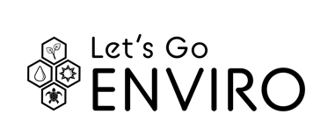
gpb.org/lets-go-enviro Name:______________________
Date:_______________________

THE VALUE OF BIODIVERSITY IN ECOSYSTEMS

DIRECTIONS: Select a specific ecosystem. It can be one local to your community or from far away. Then, identify a keystone species, an invasive species, a native species, an endemic species, a threatened or endangered species, and an indicator species that can be found within this ecosystem. In the box next to the species, write at least one way the species impacts that ecosystem. Then, write at least one way humans impact each species.

Name of Ecosystem:
Name of Species | Impact of Species on Ecosystem | Human Impact on Species
Keystone:

Invasive:

Native:

Endemic:
Threatened or Endangered:

Indicator:

