gpb.org/lets-go-enviro Name:_____________________
Date: ______________________

READING FUEL ECONOMY AND ENVIRONMENT LABELS

BACKGROUND: In this activity adapted from the Environmental Protection Agency (EPA), you will learn how to read and understand fuel economy and environment labels. The Energy Policy Act of 1992 requires the U.S. Environmental Protection Agency and the U.S. Department of Energy to provide consumers with accurate miles per gallon (MPG) information. In May 2011, the U.S. EPA and the National Highway Traffic Safety Administration announced a new design for fuel economy labels, where consumers will be able to see the vehicle’s fuel economy (miles per gallon), energy use, fuel costs, and environmental impacts. These labels are available on all models made after 2012. Formerly, the fuel economy labels only included estimated city and highway miles per gallon, and estimated annual fuel cost.

Below is an example of an EPA fuel economy and environment label, which now provides all the information consumers need to make an informed decision about buying a vehicle.

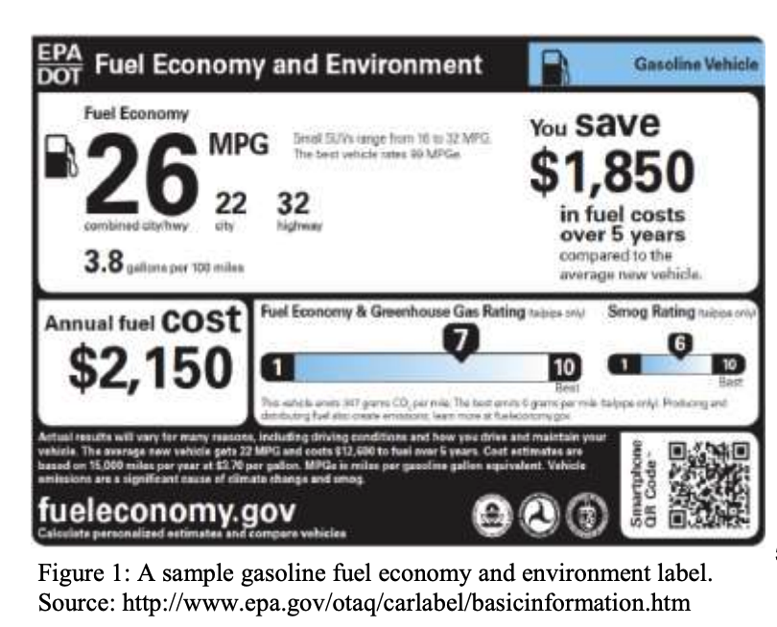

Understanding EPA Fuel Economy and Environment Labels

Fuel economy: an estimate of miles per gallon, usually refers to combined city/ highway.

Fuel consumption rate: gallons per 100 miles. This relates directly to the amount of fuel used.

Annual fuel cost: the estimated fuel cost for a year, based on the assumptions in the fine print: cost is based on 15,000 miles per year at $3.70 per gallon.

Fuel economy and greenhouse gas rating: a rating based on a scale of 1 to 10 with 10 being the best. This is based on how much carbon dioxide the car emits from the tailpipe. When cars burn fuel, they release carbon dioxide, a greenhouse gas. This means that the fuel economy of a car affects the amount of greenhouse gases the car emits.

Smog rating: the rating from 1 to 10 with 10 being the best based on vehicle tailpipe emissions that cause smog and local air pollution, including nitrogen oxide, carbon monoxide, particulate matter, non-methane organic gas, and formaldehyde

Fuel cost savings or spending: shows the difference in fuel cost over a 5 year period between the chosen vehicle compared to the average new vehicle. When calculated, a positive number indicates that the consumer saves money compared to a new average vehicle, while a negative number would indicate that a consumer spends that much more on fuel compared to the new average vehicle. The new average vehicle is estimated to get 22 MPG, driving 15,000 miles per year at a cost of $3.70 per gallon, coming to $12,600 over a five year period. The label on a new car would state “you save X” or “you spend X more” in fuel costs. For the purpose of this activity, have students indicate saving with a positive number and spending with a negative number.

DIRECTIONS: Follow the directions below to complete two fuel economy and environment labels.

- Brainstorm two dream cars. Determine the make, model, and year of each vehicle.
- Go to Fueleconomy.gov and click on “Find a Car.” Select the year of the two vehicles you wish to view, then click the make and model. Use the information presented to fill in your fuel economy and environment labels.
- To find gallons per 100 miles, click “Gallons/100 miles” under the heading “Switch Units”
- To calculate the savings over 5 years, multiply the annual fuel cost by 5. Subtract from the 5 year cost of an average new vehicle, which is $12,600 (this is listed in the fine print on the label. Note that a negative number implies that you are spending more instead of saving money.
- Round all costs to the nearest $50. This is how EPA/DOT present costs to consumers.

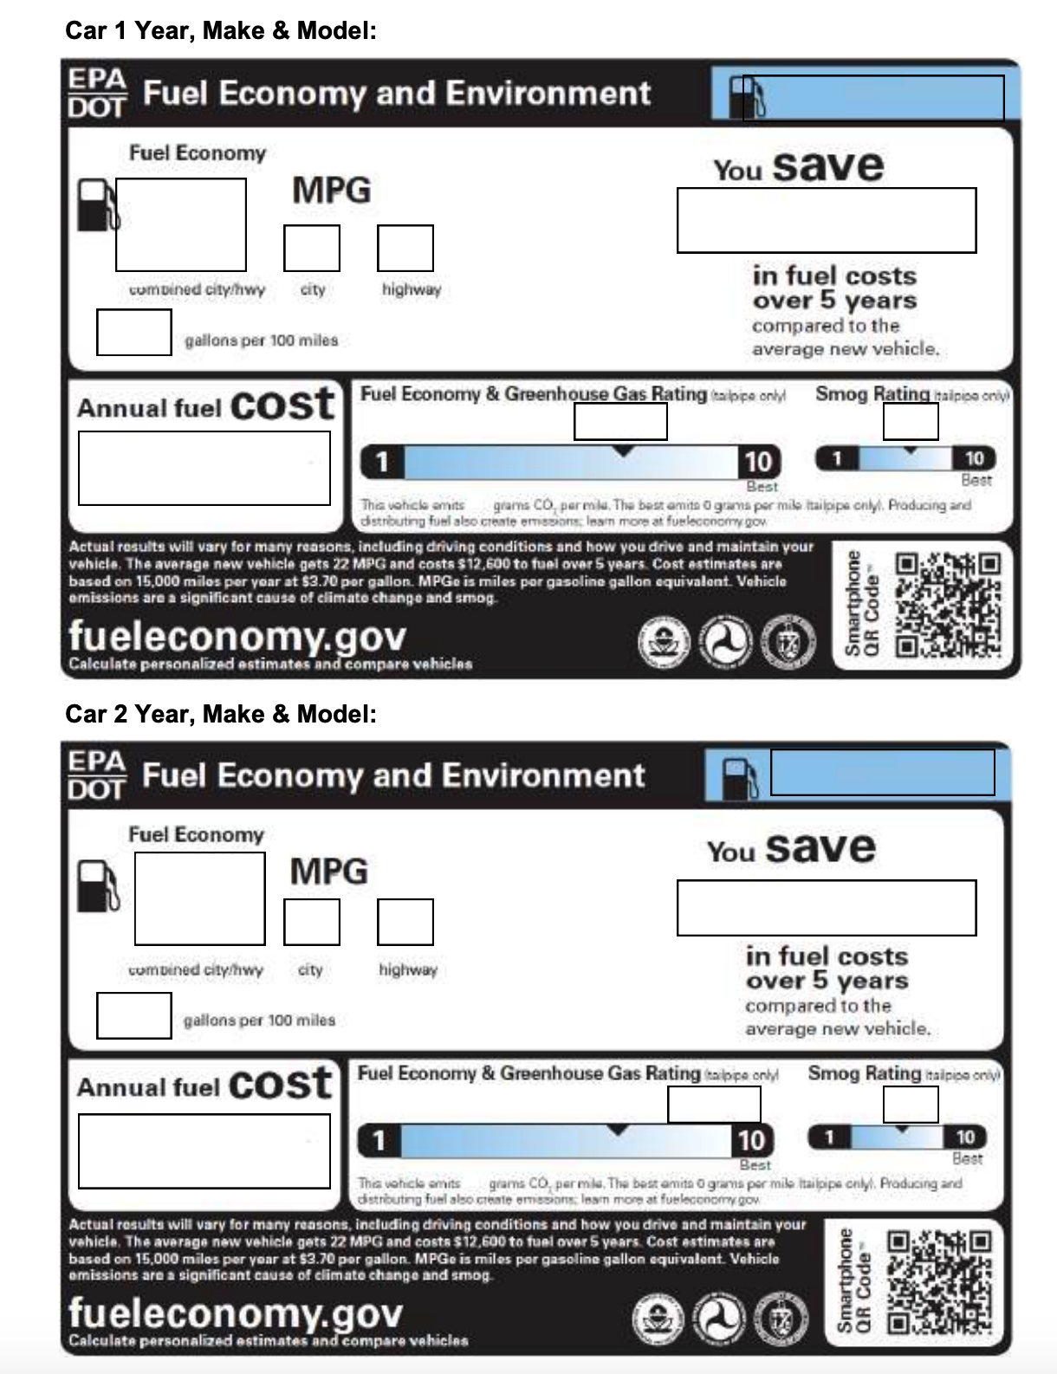

DISCUSSION QUESTIONS: After you have completed your two labels, answer the following questions using complete sentences.

1. How do your two vehicles compare? Which is more fuel efficient? Which has a lower annual fuel cost?
________________________________________________________________________________________________________________________________________________________________________________________________________________________________________________________________________________________________________________

2. Which vehicle had a higher greenhouse gas rating? What does this rating mean? How is fuel economy related to the greenhouse gas rating?
________________________________________________________________________________________________________________________________________________________
________________________________________________________________________________________________________________________________________________________

3. Of the two vehicles you researched, which would you choose to buy? Why?
________________________________________________________________________________________________________________________________________________________________________________________________________________________________________________________________________________________________________________

