Concept 26 – Inflation and the CPI Companion Activity
Teacher Key
Inflation refers to an overall rise in the price level of an economy. Price level is not the same as individual market prices. Over time, the prices of some goods and services rise while the prices of others fall. The net effect is the change in the price level. When price levels increase there is inflation. When inflation occurs, each $1 of your income buys less; inflation decreases the purchasing power of your income. To help picture this, imagine your local grocery store as the entire economy. While the price of milk or oranges or other single items may rise over time, this is NOT inflation. Inflation in this case would occur if there was a sustained increase in the total bill shoppers were paying. When families come week after week and buy similar groceries, but, the amount they are paying for those groceries increases – THAT’s inflation. To track this for a real economy, economists use a price index like the Consumer Price Index (CPI)
- Either have students navigate to Econ Express and get to Concept 26 OR you navigate for everyone to follow.
- If students are doing this independently, they simply proceed through the document as assigned. If you are leading them, have a discussion about the five items you want in the cart. As you add each item, point out it’s changing prices. Some of the items actually decrease in price over time.
- Once all the items are in the cart and students have copied the dollar amounts, click “View Consumer Price Index.” Use this opportunity to explain how the CPI is calculated and what it means. Click on the different base years to point out how changing the base year changes the CPI because formula is different.
- When ready, click “View Inflation Rates.” Again, click through different base years, but this time point out how when you change base years, the rate of inflation stays the same! Ultimately, the CPI is just an index number used for comparison. The inflation rate won’t change no matter what year is used as a base.

Answers to student questions
- Varies depending on items chosen.
- Varies depending on items chosen.
- The CPI changes because the formula is MB year X/MB base year. As you change the base year, the CPI changes.
- Varies depending on items chosen.
- The inflation rates do NOT change because you are measuring percent change between one year and another. This is the same no matter what year is used as the base.
- Some advantages are that the real market basket includes hundreds of items that the “average” household buys so it does represent a large number of consumers. Additionally, items can be added and removed from the basket over time making it flexible and relevant. A disadvantage to the CPI is it does not account for product quality. It assumes, for example, all lettuce is the same nationwide. Secondly, the CPI doesn’t fully account for individual buying habits as incomes and preferences change. These are slow to be reflected in the model.

Concept 26 – Inflation and the CPI Companion Activity
Inflation refers to an overall rise in the price level of an economy. Price level is not the same as individual market prices. Over time, the prices of some goods and services rise while the prices of others fall. The net effect is the change in the price level. When price levels increase there is inflation. When inflation occurs, each $1 of your income buys less; inflation decreases the purchasing power of your income. To help picture this, imagine your local grocery store as the entire economy. While the price of milk or oranges or other single items may rise over time, this is NOT inflation. Inflation in this case would occur if there was a sustained increase in the total bill shoppers were paying. When families come week after week and buy similar groceries, but, the amount they are paying for those groceries increases – THAT’s inflation. To track this for a real economy, economists use a price index like the Consumer Price Index (CPI)
Practice Activity: Using the prices from econexpress.org, complete the following charts.
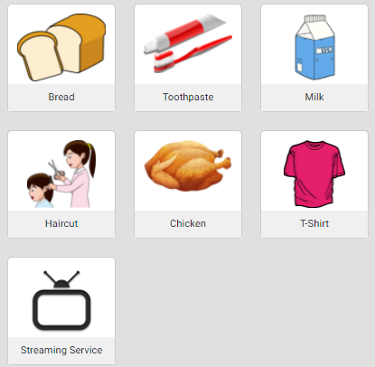
- Choose five of the items on the left and put them in your “market basket.” Record the five items you selected and their prices below. Add up the total for each year and put that number on the last row.
Product | Price Year 1 | Price Year 2 | Price year 3
TOTAL of Basket
- To find your consumer price index, we will take the total of a basket, divide it by the basket we choose as the “base” year (comparison year) and multiply by 100. After adding up your totals, click “View Consumer Price Index” and record your numbers here using Year ONE as the base year:
Year | Market Basket Price | Consumer Price Index

- Now change the base years. What do you notice happens to the Consumer Price Index? Why is this happening?

- When ready, click “View Inflation Rates” and record your inflation rates below.
Year 1 to Year 2 | Year 2 to Year 3 | Year 1 to Year 3
- Once again, click through the different base years. What do you notice about your inflation rates? Why is this the case?

- Explain a strength of measuring inflation this way and a weakness.

