Concept 17 – Law of Demand Companion Activity
Teacher Key
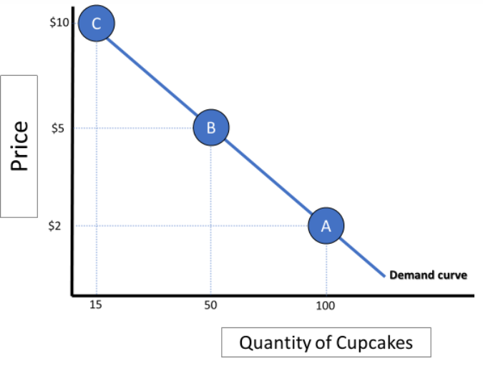
The Law of Demand states that there is an indirect relationship between the price of a good or service and the quantity of that good or service that consumers are willing and able to buy. In other words, as the price of an item increases, buyers are less willing and able to buy it and vice versa. The law of demand explains how consumers usually respond to price changes. Remember – quantity responds to price, not the other way around!

Activity: Answer the questions below and add points to the graph where appropriate. Check your work on econexpress.org
- The local bakery sells cupcakes for $2. The cupcakes are delicious and, at that price, buyers are willing to buy 100 cupcakes a day as seen on point A. The bakery decides that they would like to make more money and, without changing the cupcakes at all, raise the price to $5. Based on your knowledge of the law of demand, what do you expect will happen to the quantity of cupcakes consumers will buy? Show your answer with a point B on the graph above. The quantity of cupcakes demanded will decrease as seen on point B.

- What might happen if the bakery tries to raise the price to $10 per cupcake? Show your answer with a point C on the graph. The quantity of cupcakes would decrease again to point C on the graph above.

- If the price were $0, would consumers demand an infinite number of cupcakes in the short term? If not, what might eventually limit the quantity they would want? No, they would not be able to store them or transport extremely large quantities. Also, the law of diminishing marginal benefit would kick in and at some point even a free cupcake is not worth it.
- What would cause the demand curve to cross the Y (price) axis? A price so high that literally there would be no one who would pay it.

- Describe a time where you personally experienced the Law of Demand. Answers will vary, but should focus on something they wanted to buy, but got too expensive or something that they bought more of when it got cheaper.

Concept 17 – Law of Demand Companion Activity
The Law of Demand states that there is an indirect relationship between the price of a good or service and the quantity of that good or service that consumers are willing and able to buy. In other words, as the price of an item increases, buyers are less willing and able to buy it and vice versa. The law of demand explains how consumers usually respond to price changes. Remember – quantity responds to price, not the other way around!
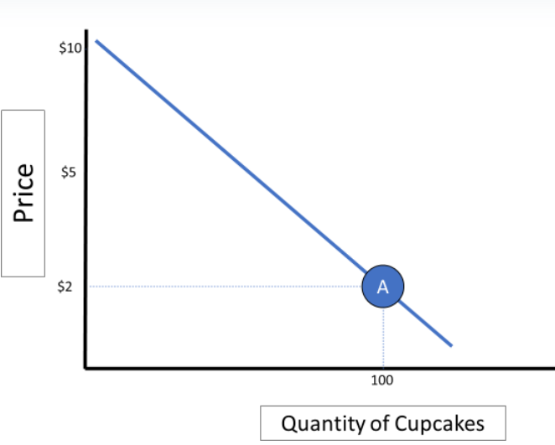

Activity: Answer the questions below and add points to the graph where appropriate. Check your work on econexpress.org if needed.
- The local bakery sells cupcakes for $2. The cupcakes are delicious and, at that price, buyers are willing to buy 100 cupcakes a day as seen on point A. The bakery decides that they would like to make more money and, without changing the cupcakes at all, raise the price to $5. Based on your knowledge of the law of demand, what do you expect will happen to the quantity of cupcakes consumers will buy? Show your answer with a point B on the graph above.

- What might happen if the bakery tries to raise the price to $10 per cupcake? Show your answer with a point C on the graph.

- If the price were $0, would consumers demand an infinite number of cupcakes? If not, what might eventually limit the quantity they would want?

- What would cause the demand curve to cross the Y (price) axis?

- Describe a time where you personally experienced the Law of Demand.

