Concept 16 – Law of Supply Companion Activity
Teacher Key
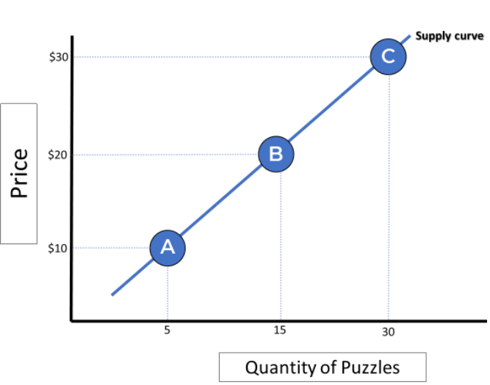
The Law of Supply states that there is a direct relationship between the market price of a good or service and the quantity of that good or service that producers are willing and able to produce. In other words, as the price of an item increases, producers want to supply more of it (to increase their revenue and profits) and vice versa. The law of supply explains how producers usually respond to price changes. Remember – quantity responds to price, not the other way around!

Activity: Answer the questions below and add points to the graph where appropriate. Check your work on econexpress.org
- Julius makes wooden puzzles which he sells at a local flea market for $10. He usually makes 5 of them and sells all 5, thus making $50 a week in revenue. A friend tells him that he could actually sell his puzzles for $20 and people would still buy them. Based on your knowledge of the law of supply, what do you expect will happen to the quantity of puzzles Julius will make? Show what you expect to happen with a point B on the graph. He would want to make more puzzles and produce at point B seen on the graph.

- What would you expect to happen if Julius could sell at $30? Show what you expect to happen with a point C on the graph. He would want to make more puzzles and produce at point C seen on the graph.

- Could this pattern go on indefinitely? If not, what might eventually limit Julius’ ability to make puzzles?
No, eventually Julius will run out of productive resources and will max out at a certain number of puzzles.
- At what point would the supply curve most likely cross the Y (price) axis? Why?
At the point where the price of producing one puzzle equals the price of of resources. Any lower than that price and the company would lose money if they produced it.
- Can you think of a real life example where a company or producer increased production of an item because people were willing to pay more for it? Answers will vary, but common examples are gas prices going up in the summer, video games that become popular, or care/collectible items.

Concept 16 – Law of Supply Companion Activity
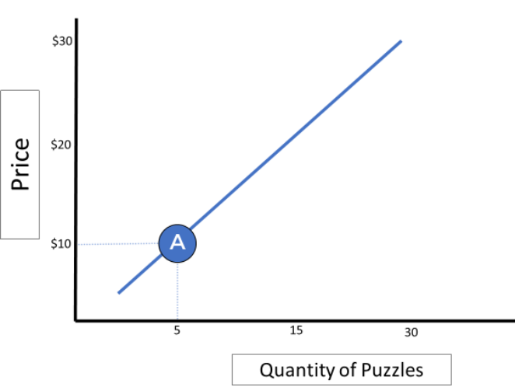
The Law of Supply states that there is a direct relationship between the market price of a good or service and the quantity of that good or service that producers are willing and able to produce. In other words, as the price of an item increases, producers want to supply more of it (to increase their revenue and profits) and vice versa. The law of supply explains how producers usually respond to price changes. Remember – quantity responds to price, not the other way around!

Activity: Answer the questions below and add points to the graph where appropriate. Check your work on econexpress.org
- Julius makes wooden puzzles which he sells at a local flea market for $10. He usually makes 5 of them and sells all 5, thus making $50 a week in revenue. A friend tells him that he could actually sell his puzzles for $20 and people would still buy them. Based on your knowledge of the law of supply, what do you expect will happen to the quantity of puzzles Julius will make? Show what you expect to happen with a point B on the graph.

- What would you expect to happen if Julius could sell at $30? Show what you expect to happen with a point C on the graph.

- Could this pattern go on indefinitely? If not, what might eventually limit Julius’ ability to make puzzles?

- At what point would the supply curve most likely cross the Y (price) axis? Why?

- Can you think of a real life example where a company or producer increased production of an item because people were willing to pay more for it?

