Chapter 5—Bald Eagle, Trout, Wood Duck

This chapter highlights species that are points of focus during the summer months. The following accounts and information on the black bear, loggerhead sea turtle, and largemouth bass will explain why these species are important wildlife resources and what is being done to responsibly manage these species. You can go directly to any of these sections by clicking on their name: Bald Eagle, Trout, Wood Duck.

Trout Species Profile

Life History

Classification
When you think about freshwater fish that are common in Georgia, bass, crappie, bream, and catfish most often come to mind. Living in the mountain streams of north Georgia are a less common group of fish, collectively known as trout. Trout prefer the cold waters that flow out of the mountains to the warmer waters of ponds and slow moving streams further south. Trout belong to the Salmon Family (Salmonidae) of fish. There are 39 species of trout and salmon that occur in North America, but only three species of trout live in Georgia.

Brook Trout, Salvelinus fontinalis, is the only species of trout that is native to Georgia. Brook trout are olive brown in color with “worm-like” markings on the upper body and vivid white edges on their lower fins. Brook trout live in small streams that occur at high elevations near the top of Georgia’s highest mountains. There are only 142 miles of stream in Georgia that support native
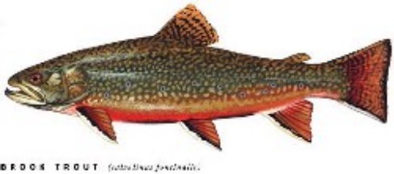
Brook trout; thereby making them the least widely distributed of the three trout species in Georgia.

Rainbow Trout, Oncorhyncus mykiss, is native to the Pacific Coast states, but they were brought to Georgia and stocked throughout the mountains in the late-1800s. Rainbow trout are readily identified by the prominent pink horizontal striped along the side of their body and the small black spots that dot their silvery-colored skin. Because rainbow trout are able to adapt to a variety of coldwater
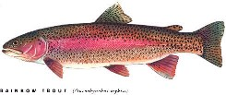
habitats, they occur in most of the mountain streams in Georgia, which makes them the most abundant trout species living in Georgia.

Brown Trout, Salmo trutta, is the third trout species that occurs in Georgia. Brown trout are native to Europe and the British Isles, but they were brought into the United States and stocked into north Georgia streams over 100 years ago. Brown trout are golden-yellow in color, and their side is dotted with tiny red spots. Brown trout prefer larger streams, which typically occur on the lower slopes of the mountains.
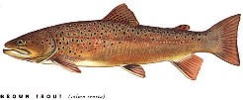

Habitat
Trout are primarily a stream-dwelling fish, but all streams in Georgia do not support trout. Because of Georgia’s warm climate, our state is the southern limit where trout can live in North America. Two primary factors determine trout habitat – water temperature and dissolved oxygen. Trout require cold water that is less than 72ºF all year long. Most streams in Georgia are cold enough to support trout in the winter months, but only the mountain streams stay below this critical temperature threshold during the summer months. Trout also require a high concentration of dissolved oxygen to survive. In general, trout require around 6 mg/L of dissolved oxygen. Compared to bass, which require about 4 mg/L and catfish, which can survive in less than 3 mg/L, you can readily see why there is a limited amount of trout habitat in Georgia.

Suitable trout habitat in Georgia only occurs in the northern part of our state, mainly in the coldwater streams that flow out of the mountains. Springheads of water bubble up from the ground at a temperature around 55ºF thereby providing a continuous trickle of cold water that flows downhill. As water merges from several springheads, a coldwater stream, capable of supporting trout, is formed. As the water continues it’s down hill path, it cascades over rocks causing tiny bubbles of air to be infused into the water, which allows the stream to maintain a high concentration of dissolved oxygen. Thickets of mountain laurel and rhododendron underneath a dense overstory canopy of oaks, hickories, poplars, and pines generally provide a sufficient amount of shade to keep the stream temperatures below 72ºF. The combination of highly oxygenated, cool water is primarily found in the narrow sliver of Appalachian Mountains that extends down into northeast Georgia. Most of this area is contained within the Chatahoochee National Forest. These public lands are managed for fish and wildlife and are open for public recreation.

The continuous flow of water carves a well defined stream channel through the boulders and bedrock that form the mountain slopes. Within the stream channel are distinct physical differences in habitat. Shallow water areas with rapidly flowing water are called riffles. Deeper areas in the stream with slower moving water are called pools, while the uniform flows that connect riffles and pools are called runs. Trout prefer pools and the cover provided behind large rocks and debris because it requires less energy to swim in these areas. Of the nearly 20,000 miles of stream in Georgia, about 5,400 miles can support trout. Only 2,800 miles have suitable habitat that provides favorable conditions for trout to reproduce successfully.

Niche & Food Habits
Trout are an important part of mountain stream ecology because they feed on a wide variety of insects and small fish that occur there. When aquatic insects, like mayflies, caddisflies, and stoneflies, become dislodged from their underwater homes and drift downstream in the current, they become an easy meal for a hungry trout. Terrestrial insects live on the land or on the leaves of streamside bushes and trees. During rainstorms or simply by accident, they sometimes fall into the water where they are quickly gobbled up by nearby fish. Terrestrial insects like ants, crickets, grasshoppers, and spiders are common food items for trout. And finally, other creatures, like small fish and crayfish can become food for trout, when they can catch them!
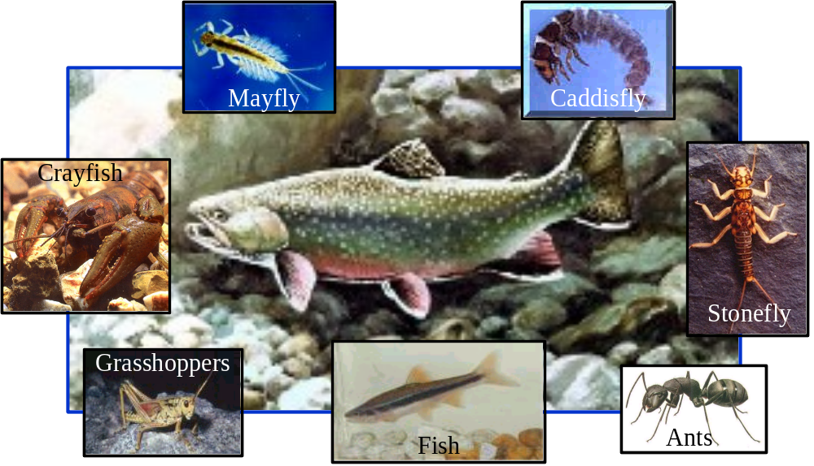

Life Cycle
Rocky stream bottoms not only support aquatic insects, which supply food for trout, but the gravel and cobble bottoms of trout streams also provide a safe and healthy environment for trout to lay their eggs. When the water temperature approaches 50ºF and the amount of day light is just the right length of time, these environmental cues signal adult trout to search for suitable gravel bottoms that make ideal spawning habitat. Rainbows lay their eggs in the spring; whereas Brooks and Browns spawn in the fall.

The female sweeps out a small area with her tail and then lays 500 to 1,000 eggs in the nest, and males fertilize the eggs with their sperm. The female then uses her tail to sweep gravel back over the fertilized eggs. Fisheries biologists call these nests, redds. Although the eggs are buried under a layer of small rocks and pebbles, they are safe from predators, like crayfish and other fish that would invade the nest and eat the eggs. The tiny spaces between the rocks also allow plenty of water to flow into the nest, bringing in fresh water and dissolved oxygen and washing away waste products. The incubation process make take a few weeks to a few months, depending on the water temperature, but the water temperature must remain below 55ºF for the eggs to hatch.

Once the eggs hatch, the newly hatched fry draw nourishment from their yolk sac while remaining buried in the redd until they reach a size where they can swim and successfully catch their own food. Feeding on plankton and tiny aquatic insects, the young trout may grow to a length of 3 or 4 inches in their first year of life. Since trout, like all fish, grow throughout their lifetime, another inch or two is added each successive year. It is rare for a wild trout in Georgia to live past 3 or 4 years of age and grow past 8-inches.

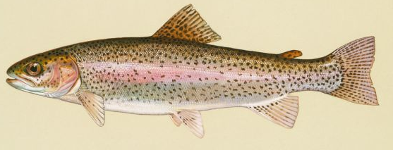
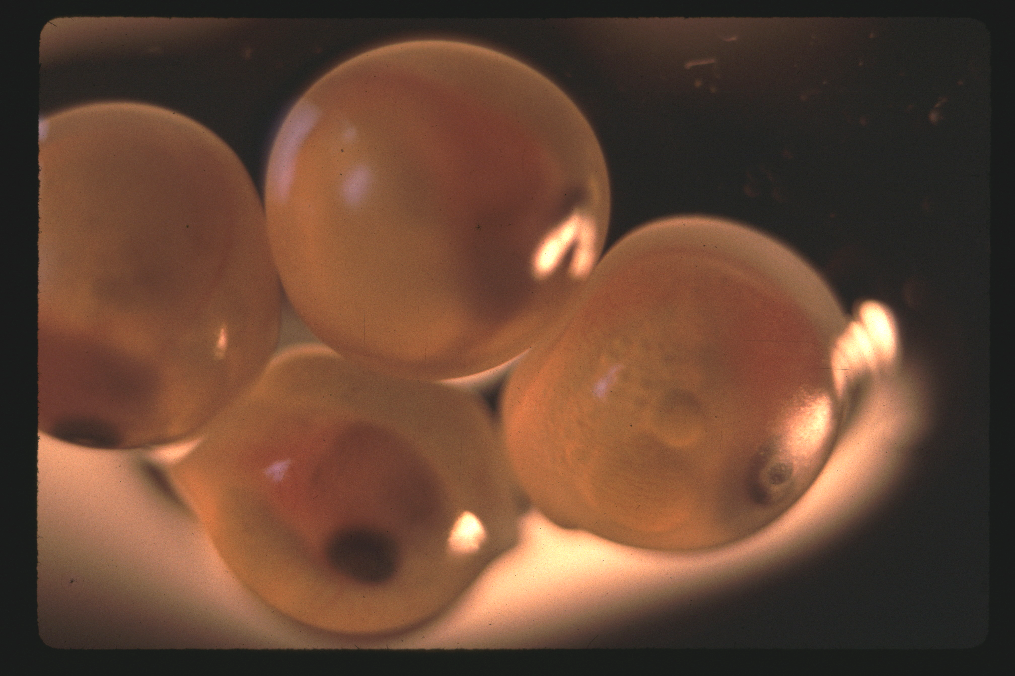
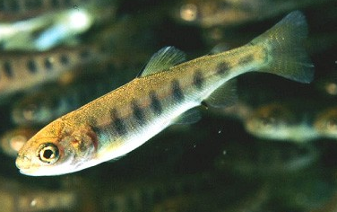
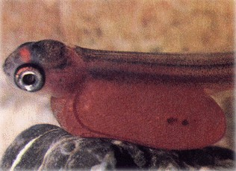
Adult
Eggs + Milt
Fertilized Eggs
Sac Fry
Fingerling
Adult
Life
Cycle
Eggs hatch in 30-45 days
Yolk absorbed in 14-30 days
Adult in 2 years

People and Trout

Recreation
For more than 100 years, people have enjoyed the sport of trout fishing as well as a good fish fry. Because trout provide good sporting qualities as well as an excellent meal, rainbow and brown trout were brought into Georgia and stocked throughout the mountains. Today, over 160,000 Georgia residents fish for trout each year. Because of this high demand for trout fishing in Georgia, the trout population must be managed wisely to prevent overharvest and the demise of trout in Georgia.

Management
Because the wild trout population cannot support the high demand for trout fishing in Georgia, the Wildlife Resources Division (WRD) developed a trout stocking program that dates back to the 1940s. The Fisheries Section of WRD is the state government agency within the Department of Natural Resources that is responsible for managing Georgia’s freshwater fishery resources. The Fisheries Section operates three trout hatcheries. The combined efforts of these facilities plus one federal trout hatchery produce and stock around 1 million trout annually into 160 streams, three reservoir tailwaters, and one large reservoir.

Trout Hatcheries
The life cycle of a trout in the hatchery is far different from its counterparts in the wild. The life cycle of a hatchery-raised trout begins with adult fish that are two or three years old. Just as in the wild, the eggs reach maturity in the female when the water temperature reaches 50ºF. When the eggs are fully mature, hatchery technicians gently squeeze the female’s abdomen and collect the eggs in a bowl. A typical three-year old female trout will yield about 2,000 eggs. After all the eggs are collected, sperm from several males is added to the bowl. The mixture is gently stirred by hand to allow all the eggs to come into contact with the sperm and thus become fertilized. Fertilized eggs are taken inside the hatching facility, and then placed into large jars or trays. Water is allowed to flow continuously over the eggs to provide oxygen and wash away waste products. Most of the fertilized eggs will hatch in about 4 to 6 weeks, depending on the water temperature.

The newly hatched fry are nourished by a large yolk sac, which protrudes from the stomach wall. The yolk contained in this sac will nourish the fry for several weeks, but once all the yolk is absorbed, the young fry are placed on an artificial diet of granulated feed, which is high in protein, vitamins, and minerals. By this time, the fry are capable of swimming and can be transferred to long, rectangular raceways. There is plenty of room in each raceway for the fry to grow. As the fry grow and start looking more like a fish, they are called fingerlings. In about 4 months, the fingerlings reach a size of 2-inches and are transferred once again, this time to raceways located outside. Once outside, trout are fed at least once a day with a nutrient rich pellet. It takes about 18 months from the time of their birth to reach a length of 9-inches, at which time, they are ready to be stocked into streams for trout anglers to catch.

When trout reach a size of 9-inches, they are weighed, counted, and loaded into stocking trucks. Each truck has a 500-gallon tank with an aeration and oxygen system.
One truck holds about 1,000 pounds of fish or nearly 3,000 catchable-sized (9-inch) trout. Once loaded, trout are transported to one of the 160 stocked streams where they are released. Stocked fish are easy and fun to catch. Because stocked trout are typically all caught from the stream within a week or two, there is very little impact to the native fish population.
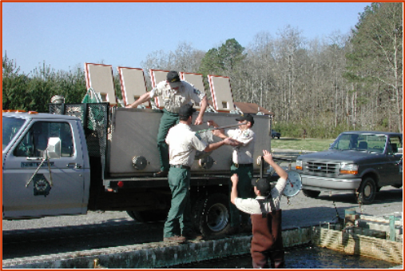

Trout are also stocked in other locations that have sufficiently cold, oxygenated water. For example, the water that passes through some dams in north Georgia meets the stringent temperature and oxygen requirements for trout. The water immediately downstream of a dam is called the tailwaters, and the tailwaters downstream from Lake Lanier (Chattahoochee River), Lake Hartwell (Savannah River), and Lake Blue Ridge (Toccoa River) are suitable for trout and receive thousands of stocked fish each year for anglers to enjoy.

There are also some remote areas in north Georgia, like the Chattooga River in Rabun County that provide very good trout habitat and are very popular with trout
anglers, but they are too difficult to stock by truck. Remote areas of the Chattooga River are stocked with trout each year using a helicopter. The water bucket that is normally used for fighting fires is transformed into a aerial trout stocking container. Once the bucket is filled with water, trout are poured into the container and then air lifted to the river.
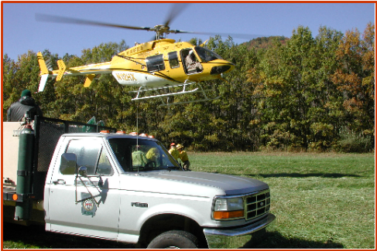

Only one large reservoir in Georgia provides trout habitat all year. Lake Burton is located in the mountains of Rabun County on the Tallulah River. It is nearly 1,900-feet above sea level. Its high elevation coupled with a continuous inflow of cool water allows trout to thrive in this reservoir environment. Each year, from 15,000 to 20,000 trout are stocked into the lake. Their purpose is to feed upon the blueback herring that were
illegally stocked into the lake several years ago. Lake Burton’s coolwater habitat and abundant food source create an environment where trout grow rapidly, often reaching weights over ten pounds in just three or four years after stocking. As you can see, the Wildlife Resources Division spends considerable time and effort to provide a variety of trout fishing opportunities to
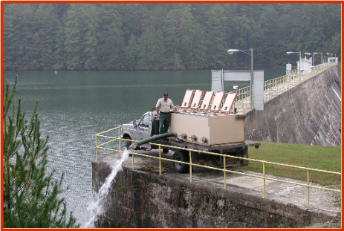
Georgia citizens. Trout stocking not only provides recreational benefits to Georgia citizens, but it also contributes over $172 million annually to the state’s economy. Without our state-operated trout hatcheries, there would be almost no trout fishing opportunities in Georgia.

Monitoring Wild Trout Populations
In addition to operating state trout hatcheries, the Fisheries Section of WRD also manages wild trout populations. One of the most important responsibilities of the Wild Trout Management Program is monitoring wild trout populations. Trout surveys are conducted every summer when teams of biologists and technicians strap on backpack electrofishing units and grab buckets and dip nets to survey trout streams across north Georgia. Every trout caught with the electrofishing gear is counted, weighed, and measured. Other fish species collected are also counted and weighed. The data collected provide useful information about trout abundance, trout growth, and spawning success. The data are also used to help biologists understand population trends as well as help develop fishing regulations to best manage the state’s trout fishery.

Currently, there are a wide variety of regulations used to manage Georgia’s trout fishery. Season Limits restrict the period of time that anglers can fish for trout. Most trout streams are classified as seasonal streams, which allow anglers to trout fish from the end of March to the end of October. Creel Limits are a method to control harvest. The creel limit on most trout streams is 8 fish. Length Limits protect certain sizes of fish. There is no length limit for trout on most streams, but a few special regulation streams like Noontootla Creek and Waters Creek have high minimum length limits in order to provide higher catch rates and the chance of catching a trophy fish. Gear Restrictions, like using a single hook instead of treble hooks or only using artificial lures, is another way to make trout fishing more challenging and ensure a higher population density. Each of these regulatory methods is designed to protect the trout population from overharvest so that all anglers can enjoy the fishery.

Improving Stream Habitat
A major component of the wild trout program in Georgia is habitat management. Because most trout waters are located in the Chattahoochee National Forest, the United States Forest Service is responsible for most of the trout habitat management efforts in Georgia. The Wildlife Resources Division assists the Forest Service, when needed, and also offers technical guidance to private landowners who request help to improve trout habitat in streams on their property. Trout need the right amount and arrangement of cover in order to protect themselves from predators, to have resting areas, and vantage points to ambush prey. Trout seem to thrive in streams that have a good balance of pools and riffles and an abundance of cover. Recent studies indicated that streams with enhanced habitat are able to support a much higher density of trout than streams with a limited amount of cover.

Threats to Trout in Georgia
Because trout require clean, cold water to survive, they are very sensitive to subtle environmental changes, especially those that may harm the population. The rapid expansion of urban development throughout the mountains poses a serious threat to Georgia’s trout habitat. Today, trout populations face habitat loss and degradation due to increased soil erosion and elevated stream temperatures.

Many of man’s land use practices elevate natural stream temperatures and thus destroy coldwater fish habitat. For example, whenever the natural vegetation growing along the streambank is destroyed and the large trees and shrubs that provide a shaded canopy over the stream channel are removed, the water is exposed to more sunlight, which eventually causes the water to
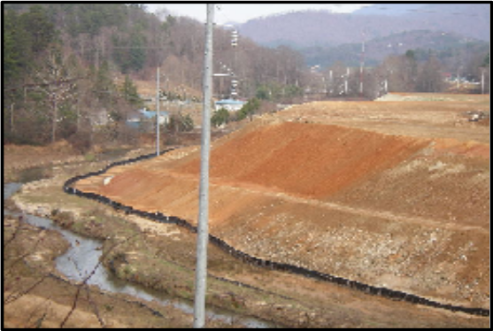
become warmer. Another major cause of trout stream warming is the construction of ponds on trout waters, which retain water long enough for it to heat up before it flows downstream. Increased stream warming can also occur when land use practices such as road
construction, timber harvesting, farming and development activities destroy the natural vegetation within 50-feet of the stream bank, thus allowing storm water to flow unchecked into the stream. Run-off from parking lots is also a major contributor to trout stream warming. Studies on some Georgia trout streams documented a 20ºF rise in stream temperature due to run-off following a heavy rain. Ensuring that large developments capture the first ½-inch of rainfall in detention ponds can go along way to keep unwanted sediments and pollutants from entering our trout streams, plus it will keep slugs of heated water from impacting our coldwater streams.

Any activity that removes vegetation and exposes bare soil is subject to cause soil particles to enter a stream when it rains, especially when those activities occur on steep slopes or near streams. This process is called sedimentation, which buries natural stream bottoms and its rocky habitat that trout need to survive, under newly deposited sediments. Sediment can adversely impact stream ecosystems by smothering redds and killing the eggs due to lack of oxygen, and reducing the habitat for bottom-dwelling fishes and aquatic insects that trout need for food. Paving dirt roads, planting grass on exposed bare soils, protecting stream banks by fencing out livestock and maintaining vegetation within 50-feet of the stream bank are ways to minimize stream sedimentation.

Because of Georgia’s growing human population and associated development, the threats to stream health continue to increase. To protect Georgia’s trout streams and prevent further habitat loss, every citizen must do what they can to ensure good land use practices, which keep soil in its proper place and protect streamside vegetation, which keeps streams cool and filters out sediments before they reach the stream. The cooperative efforts of the public and the natural resource agencies will help keep Georgia’s trout streams in healthy condition for future generations to enjoy.

Frequently Asked Questions
- Where are some good places to go trout fishing? A map of the trout streams in Georgia is available on the WRD website at www.gofishgeorgia.com. Stocked streams are highlighted in blue. The seasonally stocked streams are the best places for beginning trout anglers to learn to trout fish, and the spring and fall months are the best times to catch fish.

- What is a good way for a beginning trout angler to catch their first trout? Once you have identified a good place to go trout fishing, you will need to use the appropriate size tackle, hooks, and bait. A 5 to 6-foot long ultralight rod with a spinning or spincast reel is ideal tackle for the beginning trout angler. Light line in 4 to 6 pound test is recommended. Tie a number 10 hook to the end of the line and add one or two small weights (size BB split shot) to the line about 12-inches above the hook. Common trout baits are niblet corn, red wiggler worms, crickets, and salmon eggs. Put enough bait on your hook to cover it. Trout are usually found near the bottom in deep pools and in slower pockets and eddies behind large rocks and submerged tree limbs. Standing downstream of the place you think trout might be, cast your bait several feet upstream of your target and allow the bait to drift downstream into the target area. Slowly reel in the slack line as the bait drifts downstream. After several casts without a strike, move upstream to the next likely spot. When a trout takes the bait, you will feel several slight tugs on the line. If you feel a tugging on the line, pull the rod tip up quickly to set the hook. Remember, the trout anglers are allowed to keep 8 fish and every angler must have their own stringer. For more information, the publication, An Introduction to Georgia Trout Fishing, is available from the Fisheries Section.

- What are the state records for trout? The current state record for brook trout weighs 5 lb, 10 ounces and was caught in Waters Creek on March 29, 1986. The state record rainbow trout weighs 17 lb, 8 ounces and was caught in the Soque River on May 7, 2004. The state record brown trout was caught in the Chattahoochee River on November 12, 2001 and weighed 18 lb, 6 oz.

- Do I need a license to fish for trout? To fish for trout in Georgia, persons age 16 and older are required to purchase a fishing license plus a trout stamp. For Georgia citizens age 65 and older, a free Senior Lifetime License and trout stamp is provided by the state. For more details about fishing license requirements, refer to the License Requirements section of the annual Sport Fishing Regulations. Copies of this publication are available at most bait and tackle shops or on the WRD website at www.gofishgeorgia.com.

- Can I fish for trout on private property? To fish for trout or any other species, you must obtain the permission of the landowner and possess a valid fishing license and trout stamp. Landowners and their immediate family may trout fish on their property without a trout license. Persons who fish on private property without permission are subject to receive a trespass violation.

Project WILD and Aquatic WILD Learning Activities
Oh, Deer (just call it Oh, Trout)
Blue Ribbon Niche
Fishy Who’s Who
Micro Odyssey
Riparian Retreat
Something’s Fishy Here
Water Canaries
Watered Down History
Rolling Down the River

Resource Links
Trout Lesson Plans are available at www.blackfootchallenge.org/adoptatrout/mslessonplan.htm

A trout coloring page can be downloaded from www.zoomschool.com/subjects/fish/printouts/Laketrout

Interesting information about fish physiology can be found at www.mbstp.org/salmon.html

Trout fishing information is available at several sites including
www.gofishgeorgia.com (rules and regulations)
www.georgia-outdoors.com/ngto/ (message board for asking questions)

Trout Streams of Georgia is a map developed by WRD that highlights stocked streams, seasonal streams, and special regulation streams, and public lands. The map is available at the WRD website at www.gofishgeorgia.com. Copies of the map are also available at Fisheries Section offices.

Glossary
Angler – A person who fishes. This term typically applies to those who fish with a rod and reel for recreation.

Aquatic Insect - Insect species that’s larval and/or juvenile forms live in the water.

Dissolved Oxygen – The amount of oxygen contained in the water and available for animals to use for respiration. Dissolved oxygen originates naturally from two sources (1) as a by-product of photosynthesis in aquatic plants (i.e. algae) living in the water and (2) by the transfer of oxygen from the atmosphere into the water, such as occurs when water flows over rocks and forms air-filled bubbles that become incorporated into water.

Fingerling - A stage of fish development that occurs after the yolk sac is absorbed until they reach an arbitrary size that typically ranges from 2 to 4-inches in length.

Fry – An early stage of fish development from the time of hatching out of the egg until the yolk is absorbed.

Habitat – The surroundings where a plant or animal is ordinarily found.

Pools – Areas of deep water in streams. Trout prefer to live in pools.

Predator – An animal that catches and eats other animals for food.

Prey – An animal that is caught and eaten for food.

Redd - Shallow depression in the streambed gravel in which a female trout deposits her eggs.

Riffles - A shallow, gravelly section in a stream where water is breaking over rocks or other partially submerged organic debris with swift current. Riffles provide are excellent areas for spawning by trout and other fishes.

Runs – A relatively straight section of stream with moderate depth and uniform velocity. Pools and riffles are connected by runs.

Sedimentation – The transport of soil eroded from the land (usually by rainfall) into the stream where it settles onto the bottom and clogs the gravel and cobble. Sediment adversely impacts the stream exosystem by smothering trout redds and aquatic insects.

Spawn – The process of reproduction in fish that usually involves the laying of eggs by a female fish and the external fertilization that occurs after the eggs are deposited.

Springhead – The upwelling of water from the ground. Springheads in the mountain are the source of water for trout streams.

Stocking – The act of placing fish that were raised in a fish hatchery into a stream or lake.

Tailwaters – A stretch of river immediately downstream of a dam whose water quality and quantity are dependent upon the water that passes from the reservoir through the dam and into the downstream reach.

Terrestrial Insects - Insect species that live on the land, not in the water.

Yolk Sac – A structure in newly hatched fish (fry) that protrudes from the abdominal wall and contains a liquid nutrient source, called yolk, which sustains the fry until it is able to catch its own food.

