Chapter 4—Striped Bass, Neotropical Migrants, Wild Turkey

This chapter highlights species that are points of focus during the summer months. The following accounts and information on the black bear, loggerhead sea turtle, and largemouth bass will explain why these species are important wildlife resources and what is being done to responsibly manage these species. You can go directly to any of these sections by clicking on their name: Striped Bass, Neotropical Migrants, Wild Turkey.

NEOTROPICAL MIGRATORY BIRDS

BACKGROUND INFORMATION:

Birds are among the most easily observed wildlife species in Georgia. Unlike many of their mammalian counterparts, the vast majority of birds are diurnal, and are often fairly tolerant of human presence and observation. Of the 407 bird species that have occurred in Georgia, about 90 are neotropical migrants, which means they breed in the United States and Canada but winter in Mexico, the Caribbean, or Central and South America.
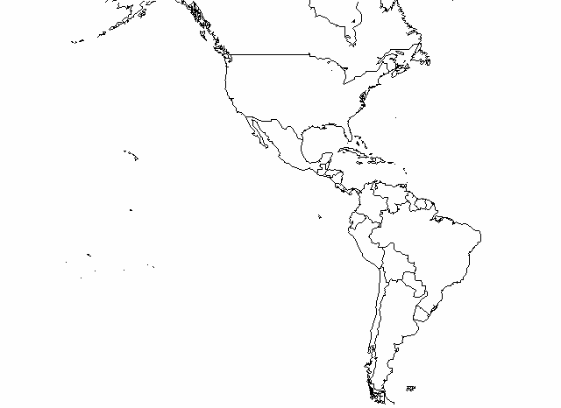
Tropic of Capricorn
Tropic of Cancer
The Tropics
Not only are many of these birds brightly colored and spectacular birds to observe, their feats of prolonged endurance and navigation during migration are truly staggering. Imagine the Ruby-throated Hummingbird (Archilochus colubris), weighing less than a penny, flying non-stop over the Gulf of Mexico, a continuous 24-hour flight of about 500 miles.

Wintering ground for our neotropical migrants.

WHO ARE OUR NEOTROPICAL MIGRANTS?

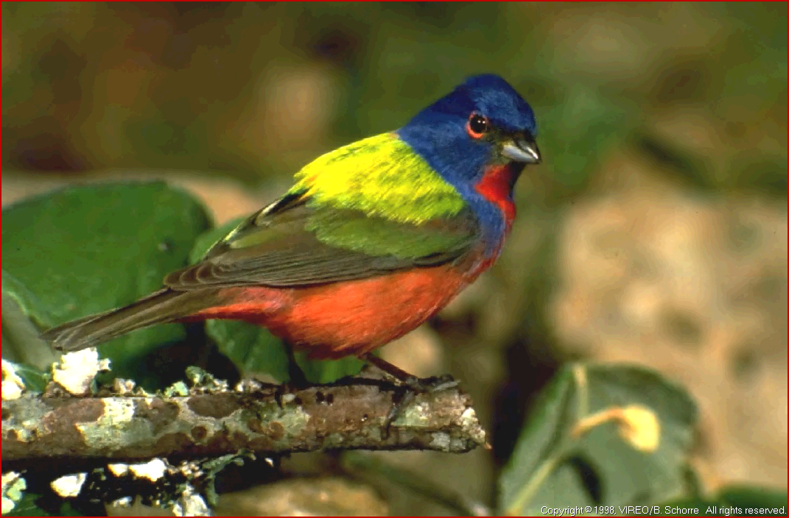
Most of our neotropical migrants are songbirds, a diverse group distinguished from other birds by a unique split voice-box that produces their often beautiful and complex songs. They range from the dazzlingly colored wood warblers and orioles, to the earth-tone thrushes and flycatchers. Neotropical migrant songbirds include the flycatchers (Tyrannidae), vireos (Vireonidae), thrushes (Turdidae), swallows (Hirundinidae), wood warblers (Parulidae), tanagers (Thraupidae), and orioles (Icteridae). Other families of birds migrate as well, and neotropical migrants are found among waterfowl (Anatidae), shorebirds (Charadriidae & Scolopacidae), vultures (Cathartidae), raptors (Accipitridae & Falconidae), cuckoos (Cuculidae), swifts (Apodidae) and hummingbirds (Trochilidae).
Painted Bunting Image from Thayer Birding Software
Though many of these species spend most of the year in the Tropics, they are very much a part of temperate ecosystems in the summer. Their ecological and economic value is so great that it is difficult to calculate. Literally tons of insects are consumed by neotropical migrants each summer and many plant species depend on these birds to disperse their seeds and pollinate their flowers. Many of these birds are also sensitive indicators of environmental health. An example of birds as bioindicators is the decline of Peregrine Falcons, Bald Eagles, and Brown Pelicans due to DDT in the environment.

WHY MIGRATE?

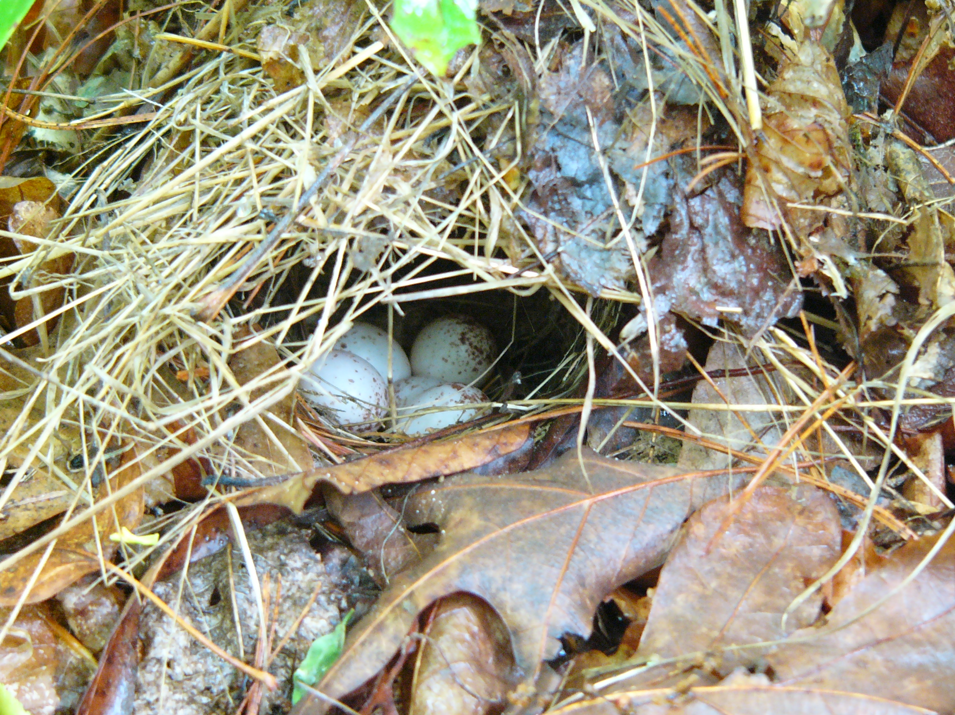
Especially among the migratory songbirds, annual mortality associated with migration is high, in some years probably exceeding 50%. Increased nesting success achieved by migrating to the temperate zone must compensate for the high mortality associated with migration, or the whole system would collapse. This pattern does tend to immerge as neotropical migrants are able to raise more offspring (4-6 eggs per clutch) than similar species that remain in the tropics (2-3 eggs per clutch). A number of factors contribute to greater temperate productivity. Species typically face less competition, less predation, and a seasonally abundant supply of food during the northern summer. They are also able to spread out over 8 times the land area available to them in the tropics.
4 Ovenbird eggs on a nest in north Georgia
This explanation of migration is a more positive one than an older notion of birds flying south to avoid cold. As many species demonstrate, if a reliable food source is available year-round, they will not migrate. Think of the tiny Golden-crowned Kinglet (Regulus satrapa) that can survive nighttime temperatures of -30°F in New England where they spend the winter.
Trade
Winds
Southward migration of Blackpoll Warblers
HOW DO BIRDS MIGRATE?

Blackpoll Warblers (Dendroica striata) weighing less than an ounce leave the coast of New England on clear autumn nights when winds are favorable and fly straight out over the North Atlantic. Their trajectory would take them straight to North Africa; however, the trade winds blow the flying birds back westward, guiding them to landfall in the tropical forests of Venezuela after a 3-4 day flight. This astounding flight is carried out without stopping, sleeping, eating, or drinking. This is the equivalent of a human athlete running 4-minute miles for 80 hours straight. How are these tiny bundles of feathers, muscle and blood capable of such astounding feats of physical endurance? Just as important, how do they know where they are going and find their way?

THE CONSTRAINTS OF FLIGHT:
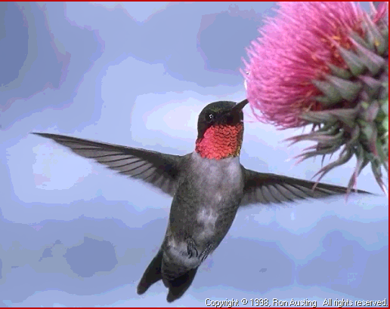
The ability to fly allows birds access to every corner of the globe. This ability comes at a great price however, as flight places major constraints on a bird’s anatomy and physiology. The most obvious hurdle that migratory birds must overcome is that of keeping a very low body weight, while still being able to generate the power to keep themselves aloft. This remarkable balance is achieved by a number of adaptations, including a simplified skeletal structure, hollow bones, and large keel that anchors powerful flight muscles to the rib cage. Some shorebirds, that fly non-stop over 6,000 miles of ocean, allow their internal organs including intestines, kidney and liver to atrophy before the flight, further reducing their weight.
Ruby-throated hummingbird Image from Thayer Birding Software
Despite all of these adaptations, migration still provides a unique challenge that calls for extreme preparation. As the late summer days begin to shorten, hormonal changes are triggered that cause birds to dramatically increase the amount of food they eat. In a period of several weeks birds can nearly double their body weight in fat, the critical fuel they will burn on long migratory flights.
NAVIGATION:
Today it is hard to imagine navigating without maps, compasses, and Global Positioning Systems, yet birds have been accurately charting their migratory journeys for millennia without such aids. A number of environmental cues, however, are available to a migrating bird. The simplest form of navigation involves following known features such as rivers, coastlines and mountain ranges. Some birds are able to use a variety of more subtle cues including the stars, solar position, sense of smell, and even the earth’s magnetic field to navigate. With this combination of tools, birds are able to navigate with remarkable accuracy. Researchers studying of Red-eyed Vireos (Vireo olivaceus), a common breeding bird in eastern deciduous forests, discovered that individual males returned to the same West Virginia territories for five years in a row. Considering that Red-eyed Vireos winter in the western Amazon Basin and northern South America, this is truly remarkable.

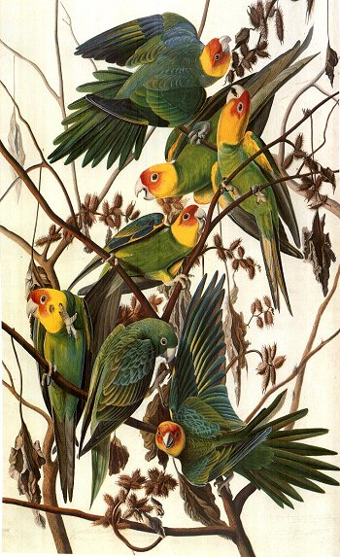
HUMANS AND NEOTROPICAL MIGRANTS

Humans have certainly noticed and appreciated birds for thousands of years. This appreciation most likely focused primarily on the culinary and costume potential of birds. Exploitative market hunting of birds for food and fashion raised concerns about bird populations as early as the 1840’s. This concern was warranted, as evidenced most tragically by the extinction of the Passenger Pigeon (Ectopistes migratorius) and Eskimo Curlew (Numenius borealis). Laws passed in the early 1900’s provided legal protection for all of our native non-game species. Now it is illegal to possess feathers, nests or eggs of any of these protected species. Several other southeastern bird species were also driven to extinction through overhunting or habitat loss. These include the Carolina Parakeet (Conuropsis carolinensis) and Bachman’s Warbler (Vermivora bachmanii).
Carolina Parakeets were killed as agricultural pests
Greatly aided by the availability of pocket field guides and affordable optics, the non-consumptive enjoyment of birds has dramatically increased since the days of market hunting. Bird watching is currently one of the most popular outdoor recreation activities in the United States, with 46 million people spending $32 billion annually on bird related sales. This in turn has generated over 860,000 jobs nation-wide.

CONSERVATION

Analyses of data from several nation-wide bird surveys have recently confirmed anecdotal evidence of population declines for many bird species. The most important is the Breeding Bird Survey that has collected data on birds since 1966 at about 2,000 sites throughout the United States and Canada. Though it is impossible to generalize about all species and regions of the country, most biologists agree that many species, especially in the eastern United States seem to be facing significant population declines. Partners in Flight has placed 100 bird species of conservation concern on a Watch List due to low or declining population trends. See Table 1 for these species that occur in Georgia.

Table 1. Partners in Flight Watch List Species that occur in Georgia.
Highest Priority | High Priority | Priority
Red-cockaded Woodpecker | Swallow-tailed Kite | Blue-winged Warbler
Kirtland’s Warbler | Short-eared Owl | Swainson’s Warbler
Bachman’s Sparrow | Red-headed Woodpecker | Nelson’s Sharp-tailed Sparrow
Golden-winged Warbler | Olive-sided Flycatcher | Seaside Sparrow
Henslow’s Sparrow | Willow Flycatcher
Saltmarsh Sharp-tailed sparrow | Brown-headed Nuthatch
 | Wood Thrush
 | Prairie Warbler
 | Bay-breasted Warbler
 | Cerulean Warbler
 | Prothonotary Warbler
 | Worm-eating Warbler
 | Kentucky Warbler
 | Canada Warbler
 | Painted Bunting
 | Dickcissel
 | Rusty Blackbird
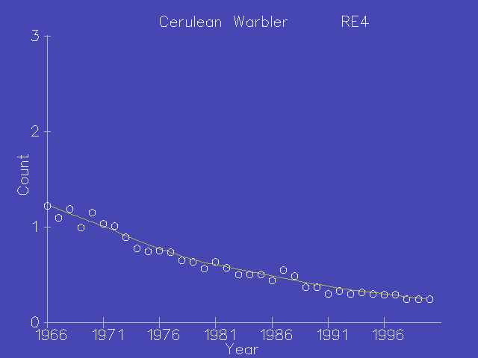
Though market hunting is a thing of the past, birds still face a number of threats. The loss and fragmentation of habitat associated with urban sprawl and development is probably the most serious threat to most bird species today. Fragmentation of habitat often allows predators and nest parasites better access to nesting birds.
Beyond habitat loss or alteration, there is an increase in dispersed mortality factors that accompany the growth of human populations and technology. These include a wide variety of problems, from bird collisions with communication towers and buildings, to predation by house cats and mortality from pesticides.
Breeding Bird Survey population data for Cerulean Warblers
House cats are often considered the largest predator on songbirds in the United States. Several estimates suggest that cats kill hundreds of millions of birds a year in the United States alone. This has led the American Bird Conservancy to start a Cats Indoors program to encourage more responsible pet ownership.
An added complication for protecting neotropical migrants is that by definition, they are highly mobile. To fully protect them, we must preserve not only their breeding grounds, but migratory stopover sites and wintering habitat as well. Because these birds winter in other countries, international cooperation is critical to their preservation. An example of this challenge was a massive hawk die-off in 1996 in Argentina, where DDT killed an estimated 20,000 Swainson’s Hawks (8% of the world’s population). DDT had been illegal for over 20 years in the United States, but is still heavily used overseas.

WHAT IS BEING DONE?

The Georgia Department of Natural Resources is committed to the conservation of all wildlife species, and is involved widely in the conservation of our neotropical migratory birds. The Non-game Wildlife Section of Georgia’s Wildlife Resources division is involved in education, research and monitoring of threatened species, ongoing management of habitat, and acquisition of important habitat for wildlife. The Non-game section helped establish birding festivals and trails to promote awareness of our neotropical migratory birds. These education efforts include the Pinewoods Bird Festival, and the Colonial Coast Birding Trail. Research projects are currently underway to establish management strategies for some of our most threatened migratory birds, such as Golden-winged, Cerulean and Swainson’s Warblers. We are also involved in a number of surveys to monitor populations of our migratory birds. WRD works with private landowners to help them manage land for our migratory birds. A good example is the collaboration with large landowners to conserve breeding habitat for Swallow-tailed Kites. Also, critical new habitat is purchased or protected in order to preserve or create habitat for migrants. The Game Management section manages large amounts of land called Wildlife Management Areas (WMA’s) for all wildlife, especially game species. These WMA’s typically provide excellent habitat for our neotropical migratory species as well.

CONCLUSION

With over 200 species of neotropical migrants nesting in the United States, there is a huge amount to learn about their various habitats, behaviors, and population status. As some of the most attractive and easily observed wildlife species, bird watching is becoming increasingly popular among people of all ages. There are a number of citizen science programs that amateur birders can become involved with that can add significantly to our knowledge of migratory birds (see below).

How can you help?
- Learn more about and enjoy Georgia’s neotropical migrants
- Improve backyard habitat for birds by providing
  - Food – plant flowering and fruiting plants, nectar and seed feeders
  - Water – dripping birds baths or small backyard ponds
  - Shelter – wide variety of plant structure from the ground up, brush piles
- Limit your use of chemical pesticides in your yard
- Keep your cats inside
- Join a local or national bird conservation organization
- Support Georgia’s Non-game Wildlife Program with direct contributions, tax check-offs, or by purchasing Wildlife Tags for your vehicle.
- Learn to be a responsible consumer. Purchase products produced in the Tropics that do not harm neotropical migratory birds. A good example is Shade Grown Coffee.

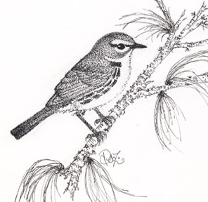
Prairie Warbler by Deb Zaremba

FREQUENTLY ASKED QUESTIONS

If I leave hummingbird feeder up in the fall will it keep the birds from migrating?

No. Day length triggers migratory behavior, not the availability of food. In fact, by leaving hummingbird feeders up year-round you have the chance that a rare western hummingbird will visit your yard. Several species western hummingbirds winter in the southeast in small numbers. If hummingbirds visit your feeder in winter, you should report them to the Rare Bird Alert, because they will not be the Ruby-throated Hummingbird, our one common breeding species.

What should I do if I see a baby bird on the ground?

Unless there is either an immediate threat (a stalking cat), or an obvious injury, leave the bird where it is. Adult birds stay with their young even after they leave the nest. Most birds’ first attempts at flight are not an unmitigated success, so most will spend some time on the ground until they get the hang of it. The baby bird is much more likely to die in captivity than in the wild.

What should I do if I find an injured bird?

There are many wildlife rehabilitators throughout the state of Georgia that are able to care for injured birds. You can access this list by calling any Wildlife Resource Division office or the Special Permit Unit at (770) 761-3044.

Where and when can I go to see migratory birds?

The best time to observe the largest number of species is during the spring and fall migration. In Georgia, the last two weeks of April form the peak of the spring migration, while September is the peak of the fall migration. In the summer breeding neotropical migrants are found across the state, but the Blue Ridge Mountain region of Georgia has the greatest diversity. Many state and national parks and wildlife management areas provide excellent bird watching opportunities. For specific sites, see Giff Beaton’s Birding Georgia listed below.

Can I keep bird feathers and nests if I find them in the wild?

No. Unless you have a salvage permit, you should leave all bird bones, feathers, eggs and nests alone. The Migratory Bird Treaty Act of 1918 decreed that all migratory birds and their parts (including eggs, feathers and nests) were fully protected. A salvage permit must be acquired from the US Fish and Wildlife Service, and is typically available to school teachers, nature centers and other educators.

What can I do to keep hawks from eating birds at my feeder?

By putting out birdseed, you attract seed eating birds. This very fact means that you are likely to attract bird predators. Hawks are fully protected predators. If you can’t accept the fact that a hawk might take one or two you really need to stop feeding the small birds.

What is a good field guide to learn about birds?

There are a number of excellent field guides available today. Some use photographs and others paintings. Generally, the paintings are considered better at capturing the variability commonly found within a single species, though much is dependant on your personal preference. Two of the top guides available today are the National Geographic Field Guide to the Birds of North America, and the Sibley Field Guide to Birds of Eastern North America.

What is shade-grown coffee, and does it really help birds?

Coffee originated as an understory plant, growing in the shade of canopy trees. Recent forms however have been developed that can live in full sun. This has led to the clearing of tropical forests and a 90% reduction of bird species in coffee plantations. Shade-grown coffee plantations remain second only to undisturbed forest for quality bird habitat. More information and locations for purchasing shade-grown coffee can be found on at www.atlantaaudubon.org, and the Smithsonian Institute http://nationalzoo.si.edu/ConservationAndScience/MigratoryBirds/Coffee/.

CITIZEN SCIENCE PROJECTS:
Generally require some basic bird identification ability, Internet access, and a place to watch birds.

Project Feeder Watch, Great Backyard Bird Count (with National Audubon Society) The Birdhouse Network, Project Pigeon Watch and others are organized by the Cornell Lab of Ornithology. Visit http://birds.cornell.edu or www.birdsource.com for more details.

Breeding Bird Survey: Require good bird identification skills by sight and sound.
Contact Non-game Wildlife office to get more information. (478) 994-1438 or visit the Patuxent Wildlife Center (USGS) site http://www.pwrc.usgs.gov/

Christmas Bird Count: Longest running citizen science project in the US.
Dates can be found at www.gos.org (web site for Georgia Ornithological Society)

BIRD CURRICULUM:

Project Flying WILD
Bird curriculum designed to help middle school students put on a bird festival. Includes many hands-on activities and events. Visit www.flyingwild.org or www.projectwild.org

Audubon Adventures – 4-6th grade curriculum. A classroom kit includes materials for 32 students: Student Newspaper, lesson plans, tips for outdoor study, hands on activities and guide to a healthy schoolyard. Visit www.atlantaaudubon.org education link.

Friends of Feathered Fliers, Interactive Educational Activity Box: Borrow for FREE!
Includes: Videos, binoculars, bird eggs, nests, lesson plans, books, and posters. Sign out from local nature centers around state. www.partnersinflight.org

Project WILD Activities www.projectwild.org
- Changing the Land
- Rare Bird Eggs for Sale
- Shrinking Habitat
- Migration Barriers (deer not birds)
- No Water Off a Ducks Back
- Hazardous Links, Possible Solutions
- Birds of Prey
- Bird Song Survey

Create Bird Habitat at home or school:

Several organizations help schools develop wildlife habitat in schoolyards for education and conservation.
Atlanta Audubon Society - www.atlantaaudubon.org
Georgia Wildlife Federation (GWF) – www.gwf.org
Both offer guidelines to create water, food, shelter and space for wildlife. For funding ideas see http://birds.cornell.edu/schoolyard

Bird Conservation Organizations:
American Bird Conservancy
Provides information on a wide range of conservation topics, such as the Cats Indoors Campaign. Cats kill hundreds of millions of birds each year in the US alone, as well as other wildlife species. – www.abcbirds.org

Local Chapters of the Audubon Society
Lead bird walks open to public of all ages. Often have monthly meetings with interesting speakers. Several have regular newsletters. Atlanta Audubon Society teaches a Master Birder Class for those interested in delving more deeply into the study of birds.

Atlanta Audubon Society
www.atlantaaudubon.org
All Georgia’s Bird clubs and local Audubon chapters can be found at
http://www.gos.org/local-ga-orgs.html

National Audubon Society
http://www.audubon.org

Partners in Flight
International cooperative group of federal, state, and private organizations working to protect migratory landbirds. www.partnersinflight.org

OTHER RESOURCES:

Birding Georgia – A Falcon Guide, Giff Beaton, 2000 – More than 100 places in Georgia to look for birds.
Annotated Checklist of Georgia Birds – Available from the Georgia Ornithological Society
Handbook of Bird Biology – Cornell Lab of Ornithology, 2004. Excellent Ornithology Text.

Birding Software – Pictures and calls for all North American Species. Natural History information on all species. Games to help learn birds.

http://www.ebird.org
http://www.hummingbirds.net - site with lots of good hummer info – migration maps – tracking northward and southward movement –

Supplemental Material (PDF files)

Bluebird Box Plans – simple plans to construct a nesting box for Eastern Bluebirds.
Nuthatch Box Plans – simple plans to construct a nesting box for nuthatches.
Screech Owl Box Plans – simple plans to construct a nesting box for Eastern Screech Owls.
Why Birds are crazy for coffee Fact Sheet – Information on “bird-friendly coffee”.
Neotropical Migrant basic Fact Sheet – Basic information about Neotropical Migrants.
Have Wings will Travel Fact Sheet – Basic information on migration.
Cat Predation Fact Sheet – Basic information on the problem of cat predation.

