Bald Eagle
Haliaeetus leucocephalus

State Status: Endangered

Federal Status: Threatened

Other Commonly Used Name(s): American eagle, white-headed eagle, Washington eagle, white-headed sea eagle, black eagle

The bald eagle is truly and all-American bird – it is the only eagle unique to North America. It ranges over most of the continent, from the northern reaches of Alaska and Canada down to northern Mexico.

While our national symbol was in danger of extinction throughout most of its range 25 years ago, the bald eagle has made a tremendous comeback, its populations greatly improving in numbers, productivity, and security in recent years.

Description
Male bald eagles generally measure 3 feet from head to tail, weigh 8 to 12 pounds, and have a wingspan of about 6 ½ feet. Females are larger, some reaching 14 pounds and having a wingspan of up to 8 feet. This striking raptor has large, pale eyes; a powerful yellow beak; and great, black talons. The distinctive white head and tail feathers appear only after the bird is 4 to 5 years old.
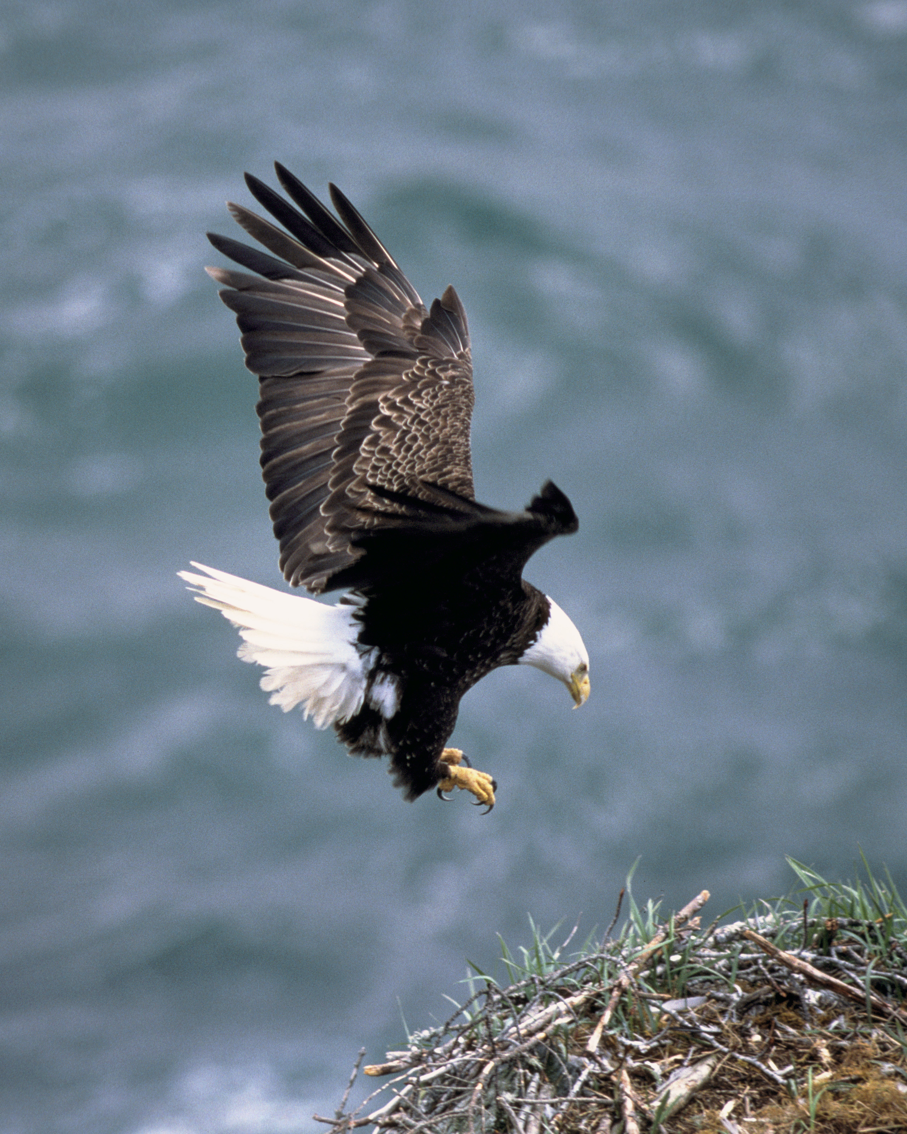

Life History
Bald eagles sometimes live 30 years or longer in the wild, and even longer in captivity. They mate for life and build huge nests in the tops of large trees near rivers, lakes, estuaries, or other open water. Nests are often re-used year after year. With additions to the nests made annually, some may reach 10 feet across and weigh as much as 2,000 pounds. Although bald eagles may range over great distances, they usually return to nest within 100 miles of where they were raised.

Bald eagles normally lay two to three eggs once a year and the eggs hatch after about 35 days. The young eagles are flying within 3 months and are on their own about a month later. However, disease, lack of food, bad weather, or human interference can result in the deaths of many eaglets. Typically fewer than half will survive their first year.

Diet
The staple of most bald eagle diets is fish, but they will feed on almost anything they can catch or find, including water birds, rodents, turtles, and carrion. In winter, northern birds migrate southward and gather in large numbers near open water areas where fish or other prey are plentiful.

Threats and Concerns
Wildlife experts believe there may have been 12,500 to as many as 37,500 nesting bald eagle pairs in the lower 48 states when the bird was adopted as our national symbol in 1782. Since that time, the eagle population has suffered from a number of factors including intentional persecution and degradation of its habitat. In 1940, noting that the national bird was “threatened with extinction,” Congress passed the Bald Eagle Protection Act, which made it illegal to kill, harass, possess (without a permit), or sell bald eagles. By the early 1960s there were fewer than 450 nesting pairs in the lower 48 states. In 1967, bald eagles were officially declared an endangered species under the Endangered Species Preservation Act, a law that preceded the Endangered Species Act (ESA) of 1973. This designation applied to all bald eagles in areas of the United States south of the 40th parallel (see map below).
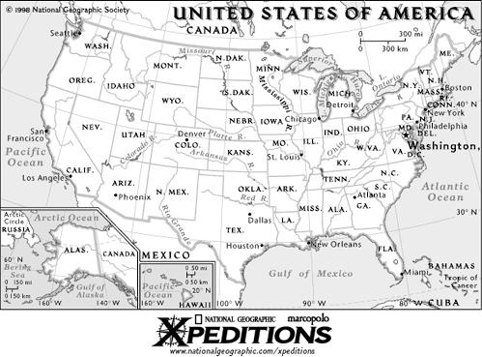

From the 1940s to the 1960s, the greatest threat to the bald eagle’s existence arose from the widespread use of DDT and other pesticides. DDT was sprayed on croplands throughout the country and its residues washed into lakes and streams. Once in the water, the toxic chemical was absorbed by small animals that were eaten by fish. The contaminated fish, in turn, were consumed by bald eagles, which gradually built up dangerous levels of the pesticide.

DDT interfered with the bald eagle’s ability to develop strong shells for its eggs. As a result, bald eagles and many other bird species began laying eggs with shells so thin they often broke during incubation or otherwise failed to hatch. Their reproduction disrupted, bald eagle populations plummeted. As the dangers of DDT became known, in large part due to Rachel Carson’s famous book Silent Spring, this chemical was banned for most uses in the U.S. in 1972. Federal and state government agencies, along with private organizations, successfully sought to alert the public about the bald eagle’s plight and to protect its habitat from further damage.

Bald eagles have few natural enemies, though males are sometimes mortally injured during territorial disputes. In general, they simply need tall, mature trees in which to construct their large nests and clean waters where they can find food. Though eagles seem to prefer an environment of quiet isolation, in recent years many eagles have demonstrated remarkable tolerance of human activities and are thriving in the face of the development that has impacted so much of their habitat.


Recovery Efforts in Georgia
In an effort to restore a healthy bald eagle population to this state, Georgia Department of Natural Resources, Wildlife Resources Division biologists used a method called hacking, a procedure adapted from the sport of falconry. At 8 weeks of age, nestling eaglets, obtained from captive breeding facilities or from wild nests in areas where surplus birds were available, were placed on manmade towers located in remote areas of suitable habitat. The eaglets were kept in an enclosure and fed by the biologists who stayed out of sight. When the birds were capable of flight, at about 12 weeks old, the enclosure around the artificial nest was opened and the birds were free to leave. Food was still provided at the release site until the birds learned to fend for themselves in the wild.

With hacking and other recovery methods, as well as habitat improvement and the banning of DDT, bald eagle populations have steadily increased. There are now nearly 4,500 adult bald eagle nesting pairs and an unknown number of young and subadults in the conterminous United States. In Georgia, there were no known nesting pairs through most of the 1970s, but since then the population has steadily increased to 83 known nesting pairs in 2004.

In 1995 the USFWS downlisted the bald eagle from endangered to threatened to reflect the species’ improved status. In 1999 the USFWS proposed to remove the bald eagle from protection under the ESA. The bald eagle has not yet been de-listed, but that will probably happen soon.

While habitat loss still remains a threat to the bald eagle’s full recovery, most experts agree that its status to date is encouraging. Soon the sight of our national symbol soaring the skies may be available for most Americans to once again behold.

Bald Eagle Frequently Asked Questions

Q: Why was the bald eagle chosen as the U.S. national symbol?
A: The bald eagle was chosen as a national symbol of the United States in 1782
because of the bird’s long life, great strength, and majestic looks.

Q: Is the bald eagle bald?
A: The bald eagle is not really bald; it actually has white feathers on its head, neck, and tail. Bald is a derivation of balde, an Old English word meaning white. The eagle was named for its white feathers instead of for a lack of feathers.

Q: How fast can a bald eagle fly?
A: The bald eagle can fly 20 to 40 mph in normal flight and can dive at speeds over 100 mph. They fly to altitudes of 10,000 feet or more, and can soar aloft for hours using wind currents.

Q: What is the bald eagles scientific name?
A: The bald eagle’s scientific name, Haliaeetus leucocephalus, means “white-headed sea eagle.” Of the eight species of sea eagles worldwide, the bald eagle is the only one that inhabits North America.

Q: What does the bald eagle eat?
A: As with all sea eagles, the primary food source for bald eagles is fish. They also feed on carrion, birds, small mammals, and reptiles.

Q: How large are bald eagles?
A: Adult eagles are about three feet from head to tail and weigh 8 to 12 pounds. As in most birds of prey, female eagles are larger than males.

Q: How long can bald eagles live?
A: Eagles can live up to 30 years in the wild; and for several years longer in captivity.

Q: Where do bald eagles nest?
A: Bald eagles generally nest in large trees near water and often use the same nest year after year. The largest bald eagle nest ever recorded was found in Florida. It was more than nine feet wide and 20 feet high and weighed more than two tons.

Q: Can bald eagles swim?
A: Bald eagles can actually swim. They use an overhand movement of the wings that is very much like the butterfly stroke.

Q: Where is the best place to see a bald eagle?
A: Each fall, the Chilkat Bald Eagle Preserve in Alaska hosts one of the world’s largest concentration of eagles as 3,000 birds congregate there to prey on salmon spawning in the shallow waters. In Georgia, the coastal region and most of the large reservoirs offer the best observation opportunities.

Teacher Resources:

Project WILD Activities
Birds of Prey
Deadly Links
Here Today, Gone Tomorrow
Planting Animals
Too Close for Comfort
Who Lives Here?
Wildlife as Seen on Coins and Stamps
Wildlife in National Symbols

Internet Links
http://endangered.fws.gov/i/b0h.html
http://magma.nationalgeographic.com/ngm/0207/sights_n_sounds/media2.html
http://www.nwf.org/wildlife/baldeagle/
http://baldeagles.org/
http://www.baldeagleinfo.com/
http://www.mbr-pwrc.usgs.gov/id/framlst/i3520id.html
http://www.eagles.org/moreabout.html
http://www.enchantedlearning.com/subjects/birds/info/Eagle.shtml

(Information provided by: GA DNR, USFWS and Smithsonian)

